Administration Local Interface

Application Startup

When the kiosk application is opened for the first time after being installed on Tiburon hardware, it presents the Select Venue Page. This page allows the Tiburon manufacturing team that is assembling and testing the system (prior to it being delivered to the venue) to select a kiosk which was configured ahead of time in the Administrative Website. Following selecting the kiosk, its configuration is pulled down from the Administrative Website through synchronization.
Unless the application is uninstalled, every time it is opened in the future it remembers which kiosk it has been configured for and starts with the Screen Saver Page.

Kiosk Application Administration Pages
The following sections describe pages the user flows through to perform administrative and maintenance functions using the kiosk application. These features are shared by Electronic Lockers and ChargeDaddy except where explicitly noted.

Administrative Login Page
Event: | Accessing the Administrative Login Page
Description: | Occurs when the user taps the screen corners to access the Administrative Login page of the kiosk.
Success Path: |  | The user taps the corners of the screen within the number of seconds and in the sequence specified in the Kiosk Security Tab of the Administrative Web Site.
 |  | The Administrative Login page appears.
This page is displayed to allow a user of the kiosk to enter a PIN code to identify themselves as an authorized user permitted to administer the kiosk.
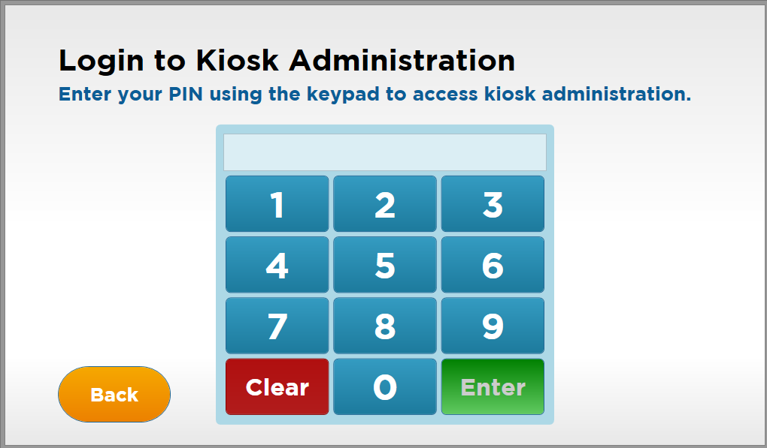
Figure 18: Administrative Login page

Event: | Kiosk Administration Login
Description: | Allows kiosk administrators to access various admin/ configuration functions
Pre-Conditions: | The user has accessed the login keypad after performing the corner unlock code.
Success Path: |  | The user enters the corner unlock code
 |  | The system displays login keypad.
 |  | The user enters their access code and clicks enter
 |  | The system displays the Administrative Home Page
Alternate Path: | User selects “Clear” button
 |  | The system clears any entered data
Alternate Path: | User selects “Back” button
 |  | The system returns to the previous screen

Administrative Home Page
This page is displayed to allow an administrator to navigate to other pages of the administration interface of the application to access settings pages for that category of settings.
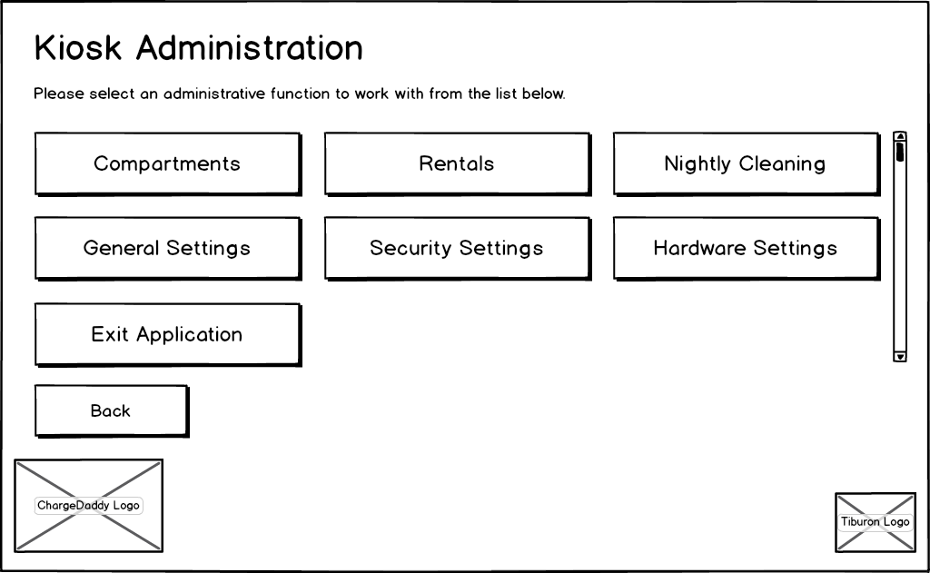
Figure 19: Administrative Home page

Event: | Displaying the Kiosk Administration Home Page
Description: | Occurs when the kiosk admin home page is first displayed.
Success Path: |  | The “Compartments” button is not visible if the user is not in the Tiburon Admin or Venue Admin role, or does not have the “Manage Compartments” permission assigned to one or more roles their user account is assigned to via the Add/Edit User Account Page.
 |  | The “Rentals” button is not visible if the user is not in the Tiburon Admin or Venue Admin role, or does not have the “Manage Rentals” permission assigned to one or more roles their user account is assigned to via the Add/Edit User Account Page.
 |  | The “Nightly Cleaning” button is not visible if the user is not in the Tiburon Admin or Venue Admin role, or does not have the “Nightly Cleaning” permission assigned to one or more roles their user account is assigned to via the Add/Edit User Account Page.
 |  | The “Security Settings” button is not visible if the user is not in the Tiburon Admin or Venue Admin role, or does not have the “Manage User Accounts” or “Manage User Roles” permission assigned to one or more roles their user account is assigned to via the Add/Edit User Account Page.
 |  | The “Exit Application” button is not visible if the user is not in the Tiburon Admin or Venue Admin role, or does not have the “Exit Application” permission assigned to one or more roles their user account is assigned to via the Add/Edit User Account Page.

Event: | Navigating to the Compartments page
Description: | Occurs when the Compartments button is clicked.
Success Path: |  | The user clicks the Compartments button.
 |  | The system navigates to the Compartments Page.

Event: | Navigating to the Rentals page
Description: | Occurs when the Rentals button is clicked.
Success Path: |  | The user clicks the Rentals button.
 |  | The system navigates to the Rentals Page.

Event: | Navigating to the Nightly Cleaning page
Description: | Occurs when the Nightly Cleaning button is clicked.
Success Path: |  | The user clicks the Nightly Cleaning button.
 |  | The system navigates to the Nightly Cleaning Page.

Event: | Navigating to the General Settings page
Description: | Occurs when the General Settings button is clicked.
Success Path: |  | The user clicks the General Settings button.
 |  | The system navigates to the General Settings Page.

Event: | Navigating to the Security Settings page
Description: | Occurs when the Security Settings button is clicked.
Success Path: |  | The user clicks the Security Settings button.
 |  | The system navigates to the Security Settings Page.

Event: | Navigating to the Hardware Settings page
Description: | Occurs when the Hardware Settings button is clicked.
Success Path: |  | The user clicks the Hardware Settings button.
 |  | The system navigates to the Hardware Settings Page.

Event: | Exiting the Application
Description: | Occurs when the Exit Application button is clicked.
Success Path: |  | The user clicks the Exit Application button.
 |  | The system exits the application.

Event: | Navigating to the Home Page
Description: | Occurs when the back button is clicked.
Success Path: |  | The user clicks the Back button.
 |  | The Home Page appears.

General Settings Page
This page is displayed to allow an administrator to select from other pages of the administration interface of the application to modify general settings.
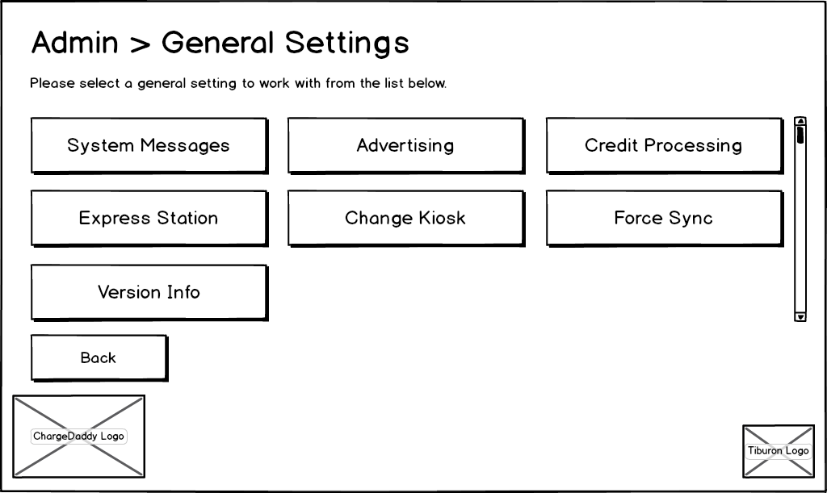
Figure 20: General Settings page
Event: | Displaying the Kiosk General Settings Page
Description: | Occurs when the kiosk general settings page is first displayed.
Success Path: |  | The “System Messages” button is not visible if the user is not in the Tiburon Admin or Venue Admin role, or does not have the “Manage System Messages” permission assigned to one or more roles their user account is assigned to via the Add/Edit User Account Page.
 |  | The “Advertising” button is not visible if the user is not in the Tiburon Admin or Venue Admin role, or does not have the “Manage Advertising” permission assigned to one or more roles their user account is assigned to via the Add/Edit User Account Page.
 |  | The “Credit Processing” button is not visible if the user is not in the Tiburon Admin role, or does not have the “Manage Credit Processing” permission assigned to one or more roles their user account is assigned to via the Add/Edit User Account Page.
 |  | The “Express Station” button is not visible if the user is not in the Tiburon Admin role.
 |  | The “Change Kiosk” button is not visible if the user is not in the Tiburon Admin role.
 |  | The “Force Sync” button is not visible if the user is not in the Tiburon Admin or Venue Admin role.

Event: | Navigating to the System Messages page
Description: | Occurs when the System Messages button is clicked.
Success Path: |  | The user clicks the System Messages button.
 |  | The system navigates to the System Messages Page.

Event: | Navigating to the Configure Advertising page
Description: | Occurs when the Advertising button is clicked.
Success Path: |  | The user clicks the Advertising button.
 |  | The system navigates to the Configure Advertising Page.

Event: | Navigating to the Configure Credit Processing Settings page
Description: | Occurs when the Credit Processing button is clicked.
Success Path: |  | The user clicks the Credit Processing button.
 |  | The system navigates to the Configure Credit Processing Settings Page.

Event: | Navigating to the Configure Express Station page
Description: | Occurs when the Express Station button is clicked.
Success Path: |  | The user clicks the Express Station button.
 |  | The system navigates to the Configure Express Station Page.

Event: | Changing the Kiosk
Description: | Occurs when the Change Kiosk button is clicked.
Success Path: |  | The user clicks the Change Kiosk button.
 |  | The system navigates to the Select Venue Page.

Event: | Forcing Synchronization with Admin Website
Description: | Occurs when the Force Sync button is clicked.
Success Path: |  | The user clicks the Force Sync button.
 |  | The system pushes configuration changes made at the kiosk up to the Admin website and pulls configuration changes made at the Admin website down to the kiosk.
 |  | The system navigates to the Home Page.

Event: | Navigating to the Version Info Page
Description: | Occurs when the Version Info button is clicked.
Success Path: |  | The user clicks the Version Info button.
 |  | The system navigates to the (TODO: Link Version Info Page).

Event: | Navigating to the Kiosk Administration Home Page
Description: | Occurs when the back button is clicked.
Success Path: |  | The user clicks the Back button.
 |  | The Kiosk Administrative Home Page appears.

Compartments Page
This page is displayed to allow the administrator to view status of compartments.
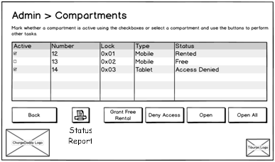
Figure 21: Kiosk Admin Compartments page
 | Event: |  | Displaying the Compartments / Lockers List Page
 | Description: |  | This page allows various Administrative Actions to be performed on local kiosk compartments / lockers.
 | Pre-Conditions: |  | Tiburon Admin or Venue Admin is logged into the kiosk application and clicks “Compartments” (ChargeDaddy) or “Lockers” (Electronic Lockers) from the Administrative Home Page.
 | Success Path: |  |  |  | The page title reads “Administration > Compartments” for ChargeDaddy and “Administration > Lockers” for Electronic Lockers.
 |  |  |  |  | The page instructions read as indicated in Figure 21: Kiosk Admin Compartments page for ChargeDaddy. For Electronic Lockers, all instances of the word “compartment” should read “locker”.
A scrollable grid is displayed listing the following details for each locker / compartment contained on the kiosk:
- Active (toggleable checkbox that indicates whether the locker / compartment is currently active)
- Number (number corresponding to a number which is physically affixed to the locker / compartment unit)
- Lock (Hex number indicating the dipswitch assignment of the hardware lock for the locker / compartment unit)
- Type (The compartment type name associated with the compartment)
- Status (current status of the locker / compartment – includes: Rented, Free, Access Denied)
 |  |  |  | The following buttons are displayed in a disabled state: Deny Access, Open, Grant Free Rental
 |  |  |  | The following buttons are displayed in an enabled state: Back, Open All, Print
 |  |  |  | The following logos are displayed: ChargeDaddy (for ChargeDaddy) or Electronic Lockers (for Electronic Lockers), Tiburon Lockers
 | Assumptions: |  | If no means of printing is configured and available, the “Print” button will be disabled.

Event: | Toggling Active / Inactive Status of Compartment / Locker
Description: | This function allows the Active Status of a compartment / locker to be changed from Active (checked) to Inactive (not checked) or from Inactive (not checked) to Active (checked).
Pre-Conditions: | Tiburon Admin or Venue Admin is logged into the kiosk application and clicks “Compartments” (ChargeDaddy) or “Lockers” (Electronic Lockers) from the Administrative Home Page.
Success Path: |  | The user “clicks” a checkbox in the “Active” column of the data grid.
 |  | If checkbox is checked, the checkbox is unchecked and the Active Status of the compartment / locker is asynchronously changed to Inactive.
 |  | If checkbox is unchecked, the checkbox is checked and the Active Status of the compartment / locker is asynchronously changed to Active.
 |  | If the compartment / locker is rented and its Active Status is set to Inactive, prompt the user to answer whether they want to reassign the rental or end the rental. If user chooses yes to reassign the rental, redirect to Change Compartment Page. If user chooses yes to end rental, redirect to Rental End Page.
 |  | Send an email notification to Tiburon that the compartment was disabled
Assumptions: | Denying Access does not change the Active Status

Event: | Printing of the Status Report
Description: | This function allows the user to print the current state of the datagrid on this (Compartments List) page.
Pre-Conditions: | Tiburon Admin or Venue Admin is logged into the kiosk application and clicks “Compartments” (ChargeDaddy) or “Lockers” (Electronic Lockers) from the Administrative Home Page.
Success Path: |  | The user “clicks” the “Print” button.
 |  | The contents of the datagrid on this (Compartments List) page is printed.
Assumptions: | - A means to print the contents of the datagrid on this (Compartments List) page has been configured and is available  - If no means of printing is configured and available, the “Print” button will be disabled.
Event: | Selecting a Compartment / Locker Row in the Datagrid
Description: | This function allows additional administrative actions to be taken on a single compartment / locker.
Pre-Conditions: | Tiburon Admin or Venue Admin is logged into the kiosk application and clicks “Compartments” (ChargeDaddy) or “Lockers” (Electronic Lockers) from the Administrative Home Page.
Success Path: |  | The user “clicks” on one row in the datagrid.
 |  | The row in the datagrid is highlighted.
 |  | The following buttons become enabled: Deny Access, Open Grant Free Rental.
 |  | If the selected compartment / locker status is NOT “Rented”, the “Grant Free Rental” button becomes enabled.
 |  | If the status of the selected compartment / locker is “Access Denied”, the “Deny Access” button text is changed to “Allow Access”.

Event: | Denying Access to a Locker / Compartment
Description: | This function allows an user to deny access to a locker / compartment except by a Tiburon Admin or Venue Admin.
Pre-Conditions: | - Tiburon Admin or Venue Admin is logged into the kiosk application and clicks “Compartments” (ChargeDaddy) or “Lockers” (Electronic Lockers) from the Administrative Home Page.  - A row has been selected in the datagrid on this (Compartments List) page.  - The “Deny Access” button is enabled  - The selected compartment / locker is NOT in an “Access Denied” status
Post-Conditions: | - If the locker / compartment is currently rented, the rental will continue, but the renter will not be able to access it.  - The locker will not be accessible during the nightly cleaning.
Success Path: |  | The user “clicks” on the “Deny Access” button.
 |  | The status of the selected compartment / locker changes to “Access Denied”.
 |  | The text of the “Deny Access” button is changed to “Allow Access”.
 |  | The screen displays a message stating that no one except for a Tiburon Admin or Venue Admin can access the selected locker.
Assumptions: | - Denying access to a compartment / locker will be handled asynchronously, similar to the Active / Inactive checkbox toggling.  - Denying Access does not change the Active Status

Event: | Allowing Access to a Locker / Compartment
Description: | This function allows an user to Allow Access to a locker / compartment by users other than a Tiburon Admin or Venue Admin.
Pre-Conditions: | - Tiburon Admin or Venue Admin is logged into the kiosk application and clicks “Compartments” (ChargeDaddy) or “Lockers” (Electronic Lockers) from the Administrative Home Page.  - A row has been selected in the datagrid on this (Compartments List) page.  - The “Deny Access” button is enabled (with its text reading “Allow Access”).  - The selected compartment / locker IS in an “Access Denied” status
Post-Conditions: | The locker will resume normal functionality, including becoming accessible during nightly cleaning.
Success Path: |  | The user “clicks” on the “Deny Access” button (with its text reading “Allow Access”).
 |  | The status of the selected compartment / locker changes to whatever its previous status was (“Rented“ if the locker is currently being rented and the rental period did not expire while the locker was in an “Access Denied” state, or “Free” if the locker is not currently being rented, including through expiration of a rental).
 |  | The text of the “Deny Access” button is changed back to “Deny Access”.
 |  | The screen displays a message stating that the locker / compartment is now accessible for normal use.
Assumptions: | Allowing access to a compartment / locker will be handled asynchronously, similar to the Active / Inactive checkbox toggling.

Event: | Allowing User to Return to Previous Page
Description: | This function allows the user to navigate to the previous page
Pre-Conditions: | - Tiburon Admin or Venue Admin is logged into the kiosk application and clicks “Compartments” (ChargeDaddy) or “Lockers” (Electronic Lockers) from the Administrative Home Page.
Success Path: |  | The user “clicks” on the “Back” button.
 |  | The application navigates back to the Administrative Home Page.

Event: | Open a Single Compartment / Locker
Description: | This function allows the user to perform an Administrative Open function on a locker / compartment. This function does not change the status of a current rental.
Pre-Conditions: | - Tiburon Admin or Venue Admin is logged into the kiosk application and clicks “Compartments” (ChargeDaddy) or “Lockers” (Electronic Lockers) from the Administrative Home Page.  - A row has been selected in the datagrid on this (Compartments List) page.  - The “Open” button is enabled.
Success Path: |  | The user “clicks” on the “Open” button.
 |  | The selected locker / compartment is opened and it’s LED is flashed (Color TBD).
 |  | The Compartment is Open Page is displayed.
Exception Path: | - If the selected compartment / locker is already open, a message indicating this is displayed.  - Any hardware exception (I/O) will be logged.

Event: | Open All Compartments / Lockers
Description: | This function allows the user to perform an Administrative Open function on all lockers / compartments. This function does not change the status of a current rental.
Pre-Conditions: | - Tiburon Admin or Venue Admin is logged into the kiosk application and clicks “Compartments” (ChargeDaddy) or “Lockers” (Electronic Lockers) from the Administrative Home Page.
Success Path: |  | The user “clicks” on the “Open All” button.
 |  | The All Compartments Are Open Page is displayed.
Notes: | The actual hardware calls to open all the compartments / lockers are performed on load of the All Compartments Are Open Page instead of on this page since the lockers which are potentially already opened will simply be skipped / not reported back to the user as already being open.

Event: | Grant a Free Rental
Description: | This function allows the user to navigate to a screen on which the user can grant a free rental to a compartment / locker.
Pre-Conditions: | - Tiburon Admin or Venue Admin is logged into the kiosk application and clicks “Compartments” (ChargeDaddy) or “Lockers” (Electronic Lockers) from the Administrative Home Page.  - A row has been selected in the datagrid on this (Compartments List) page.  - The status of the compartment / locker in the selected row is NOT “Rented.”  - The “Grant Free Rental” button is enabled.
Success Path: |  | The user “clicks” on the “Grant Free Rental” button.
 |  | The Grant Free Rental Page is displayed.

Compartment Is Open Page

This page is displayed to inform venue personnel that a remote administrator has opened a compartment.

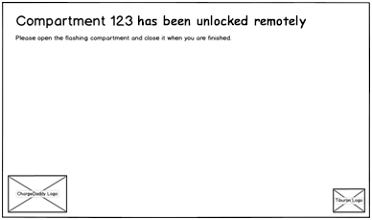
Figure 22: Compartment Is Open page
Event: | Inform Personnel that Compartment / Locker is Open
Description: | This page is displayed to inform venue personnel that a compartment / locker has been opened via a remote administrative function.
Pre-Conditions: | - A Tiburon Admin or Venue Admin has selected a row in the datagrid on the Compartments Page.  - The compartment referenced by the selected datagrid row was not already open.  - The user “clicked” the “Open” button on the Compartments Page.  - The compartment / locker was physically unlocked and its LED flashed.
Success Path: |  | The page title reads as indicated in Figure 22: Compartment Is Open page for ChargeDaddy. For Electronic Lockers, all instances of “compartment” should read “locker.”
 |  | The user opens the flashing / unlocked compartment / locker within a configurable time out period.
 |  | The user closes the compartment / locker.
 |  | The locker / compartment is locked.
 |  | The Compartments Page is displayed.
Alternate Path: |  | The page title reads as indicated in Figure 22: Compartment Is Open for ChargeDaddy. For Electronic Lockers, all instances of “compartment” should read “locker.”
 |  | The user does not open the flashing / unlocked compartment / locker within a configurable time out period.
 |  | The compartment / locker is locked.
 |  | The Compartments Page is displayed.
Exception Path: | Any hardware exceptions that might happen (I/O) during locking of compartment / locker will be logged. Any hardware exceptions that might happen (I/O) during the unlocking of a compartment / locker will be logged on the Compartments Page, where the unlock is actually performed.
Assumptions: | - There will be configurable time period in which the user must open the compartment / locker before it re-locks and the Compartments Page is displayed.  - There will be no configurable time period in which the user must close the compartment – i.e. the locker can remain open indefinitely for an Administrative Open function.

All Compartments Are Open Page
This page is displayed to prevent inform venue personnel that a remote administrator has all compartments unlocked.

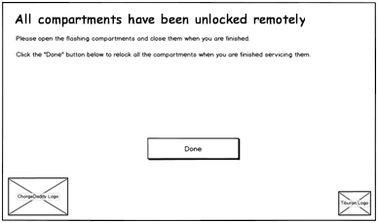
Figure 23: All Compartments Are Open
Event: | Open All Lockers / Compartments
Description: | This page is displayed when an administrative unlock function on all compartments / lockers has been performed, inform an user that all compartments / lockers have been unlocked, and allow an user to signify they are done accessing lockers so that they may all be relocked. This function does not change the status of a current rental.
Pre-Conditions: | - A Tiburon Admin or Venue Admin was on the Compartments Page.  - The user “clicked” the “Open All” button on the Compartments Page.
Success Path: |  | The page title reads as indicated in Figure 23: All Compartments Are Open for ChargeDaddy. For Electronic Lockers, all instances of “compartment” should read “locker.”
 |  | Each compartment / locker is unlocked and their LED lights are flashed. All compartments are opened at once, NOT in a successive form like indicated in the Nightly Cleaning page.
 |  | The user opens and closes at least one compartment / locker, within a configurable timeout, up to all compartments / lockers on the kiosk. NOTE: once the first compartment / locker is opened, timeouts no longer apply and the “Done” button must be “clicked” to relock the compartments / lockers and leave the page.
 |  | When the user has finished opening / closing lockers / kiosks, they “click” the “Done” button.
 |  | All compartments / lockers are locked at once.
Alternate Path: |  | The page title reads as indicated in Figure 23: All Compartments Are Open for ChargeDaddy. For Electronic Lockers, all instances of “compartment” should read “locker.”
 |  | Each compartment / locker is unlocked and their LED lights are flashed. All compartments are opened at once, NOT in a successive form like indicated in the Nightly Cleaning page.
 |  | The user does not open one of the flashing / unlocked compartment / locker within a configurable time out period.
 |  | All compartments / lockers are locked.
 |  | The Compartments Page is displayed.
Exception Path: | Any hardware I/O exceptions that might happen must be logged.
Assumptions: | - There will be configurable time period in which the user must open the first compartment / locker before it re-locks and the Compartments Page is displayed.  - Once the first locker / compartment is opened, there will be no further timeouts – the user must “click” the “Done” button to lock all compartments  - There will be no configurable time period in which the user must close the compartment – i.e. the locker can remain open indefinitely for an Administrative Open function.

Grant Free Rental Page
This page is displayed to allow the administrator to grant a free rental at a compartment that was selected from the Compartments page.
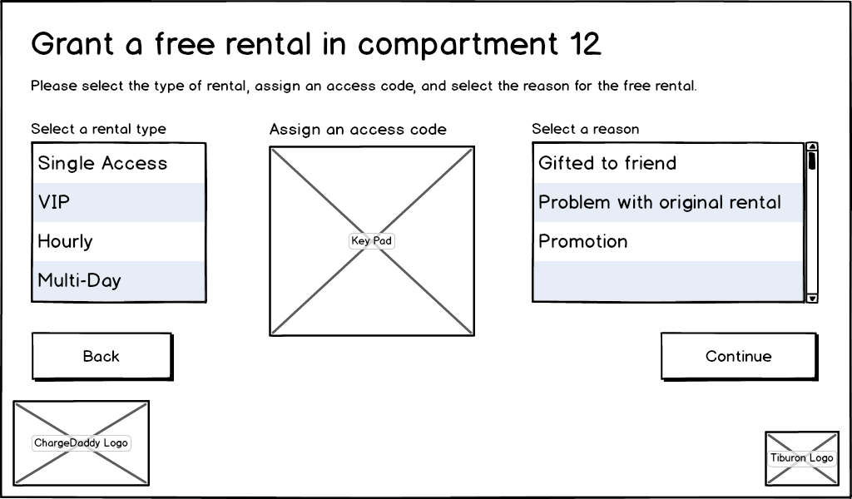
Figure 24: Grant Free Rental page

Event: | Display Grant a Free Rental Page
Description: | This displays a page in which a Tiburon Admin or Venue Admin can grant a free rental of a locker / compartment on a locker / compartment which is not currently being rented.
Pre-Conditions: | - A Tiburon Admin or Venue Admin has selected a row in the datagrid on the Compartments Page.  - The compartment referenced by the selected datagrid row was NOT in a status of “Rented.”  - The “Grant Free Rental” button on the Compartments Page was enabled and clicked.
Success Path: |  | The page title reads “Grant a free rental in compartment [compartment number]” for ChargeDaddy and “Grant a free rental in locker [locker number]” for Electronic Lockers.
 |  | The page instructions read as indicated in Figure 24: Grant Free Rental page for both ChargeDaddy and Electronic Lockers.
 |  | A list box for electing a rental type is displayed as in Figure 24: Grant Free Rental page (Note: this is based on what rental types are active on the kiosk as configured in Payment and Retrieval Tab.)
 |  | The standard Access Code Keypad Control (refer to Administrative Login Page) is displayed.
 |  | A scrollable list box containing all possible reasons for granting a free rental are displayed (Note: this is populated via a database lookup table which has been pre-populated from a list provided by Tiburon Lockers).
 |  | The “Back” button is displayed in an enabled state.
 |  | The “Continue” button is displayed in a disabled state.
 |  | The following logos are displayed: ChargeDaddy (for ChargeDaddy) or Electronic Lockers (for Electronic Lockers), Tiburon Lockers.

Event: | Grant a Free Rental
Description: | A Tiburon Admin or Venue Admin grants a free rental on a compartment / locker that is NOT in a “Rented” state.
Pre-Conditions: | - A Tiburon Admin or Venue Admin has selected a row in the datagrid on the Compartments Page.  - The compartment referenced by the selected datagrid row was NOT in a status of “Rented.”  - The “Grant Free Rental” button on the Compartments Page was enabled and clicked.
Success Path: |  | The user “clicks” one value in the “rental type” list box.
 |  | The user enters an access code for the rental.
 |  | The user “clicks” one value in the “reason for granting free rental” list box.
 |  | The “Continue” button becomes enabled.
 |  | The user presses the “Continue” button, the reason for granting a new rental is recorded, a new rental is generated, the compartment / locker is unlocked, and the Open Compartment Page is displayed.
Alternate Path: |  | The user “clicks” the “Back” button and the Compartments Page is displayed.
Exception Path: | - The “Rental Type”, “Access Code”, and “Reason for Granting a Free Rental” are all required.  - Access Code must be unique to all active rentals at the kiosk.

Rentals Page
This page is displayed to allow the administrator to view active rentals to perform operations on them.
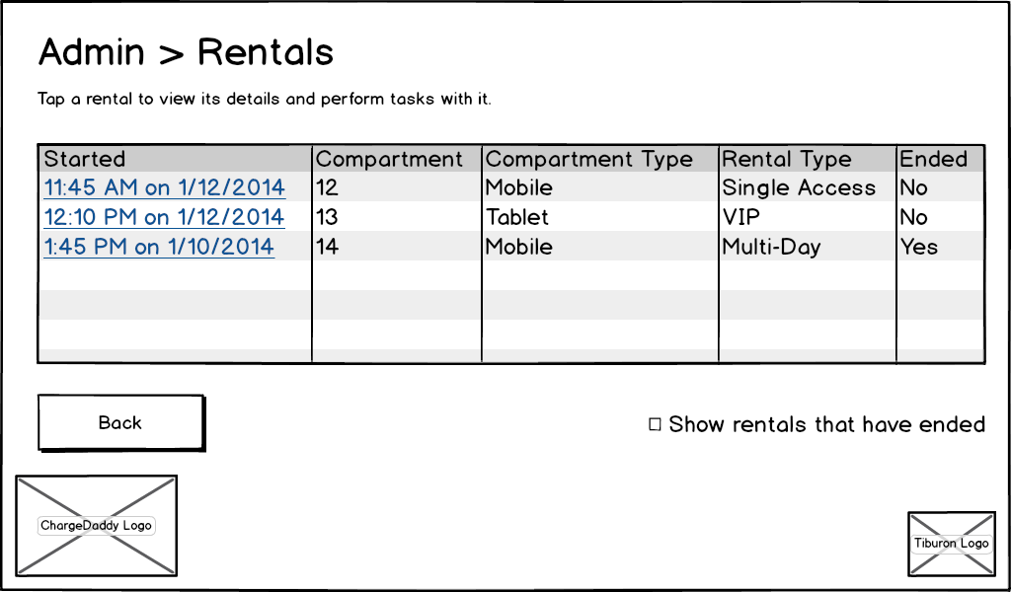
Figure 25: Rentals page
Event: | View Details and Perform Administrative Actions on Active Rentals
Description: | This page allows a Tiburon Admin or Venue Admin to view a list of all current rentals and navigate to a the Rental Details page for a selected rental.
Pre-Conditions: | - Tiburon Admin or Venue Admin is logged into the kiosk application and clicks “Rentals” on the Administrative Home page.
Success Path: |  | The page title and instructions read as indicated in Figure 25: Rentals page.
A scrollable grid is displayed listing the following details for each active rental sorted by the time of the rental descending on the local kiosk:
- Started (start date and time for each active rental as set on the Open Compartment page)
- Compartment (ChargeDaddy) / Locker (Electronic Lockers) (locker / compartment number, NOT lock number as configured on Add/Edit Compartment Type Page and Add/Edit Compartment Page)
- Compartment Type (i.e.: Mobile, Tablet, Small, Medium, Large, etc. as configured on Add/Edit Compartment Type Page and Add/Edit Compartment Page).
- Rental Type (Single Access, VIP, Hourly, Multi-Day as selected when the rental was created on the Select Rental Type Page).
The “Back” button is displayed in an enabled state.
The “Show rentals that have ended” checkbox is displayed in an UN-checked state
 |  | The following logos are displayed: ChargeDaddy (for ChargeDaddy) or Electronic Lockers (for Electronic Lockers), Tiburon Lockers.
 |  | The user “double-clicks” on a row in the datagrid.
 |  | The Rental Details page is displayed for the rental referenced by the double-clicked row.
Alternate Path:  Alternate Path: |  | The user “checks” the “Show rentals that have ended” checkbox.  All active and ended rentals for current day and previous day are shown in the datagrid  The user “clicks” the “Back” button and the Administrative Home page is displayed.
Assumptions: | When the “Show rentals that have ended” checkbox is checked, all active and ended rentals for the current day and previous day are shown in the datagrid.

Rental Details Page
This page is displayed to allow the administrator to review the details of an individual rental and perform other tasks related to it.

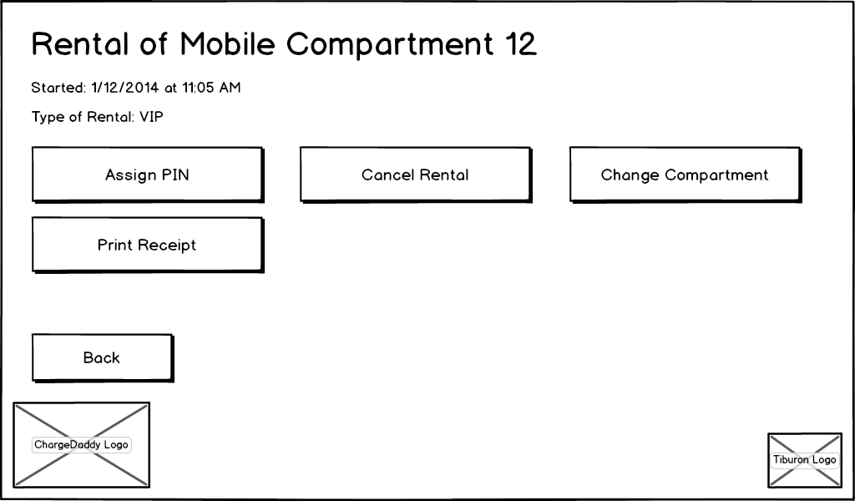
Figure 26: Rental Details page
Event: | Display the Rental Details Page
Description: | This page allows a Tiburon Admin or Venue Admin to perform administrative actions on a currently rented locker / compartment.
Pre-Conditions: | - Tiburon Admin or Venue Admin has “double-clicked” a row in the datagrid on the Rentals Page.
Success Path: |  | The page title reads “Rental of a [type] Locker [locker number]” for Electronic Lockers and “Rental of [type] Compartment [compartment number]” for ChargeDaddy.
The page instructions include
- “Started: [date] at [time]”
- Type of Rental: [type]”
The following buttons are displayed:
- Assign PIN (enabled only if the rental is active and the system is configured to allow PIN access to a compartment / locker).
- Cancel Rental (enabled only if the rental is active)
- Change Compartment (ChargeDaddy) / Change Locker (Electronic Lockers) (enabled only if the rental is active)
- Print Receipt
  - Enabled only if selected rental is not active
  - Displayed only if a printer is configured and has paper
- Back
 |  | The following logos are displayed: ChargeDaddy (for ChargeDaddy) or Electronic Lockers (for Electronic Lockers), Tiburon Lockers.
Assumptions: | - Printing of receipt is enabled only for non-active, Electronic Lockers rentals when the printer is functional and contains paper.
Event: | Assign PIN for Rental
Description: | This page allows a Tiburon Admin or Venue Admin to change the access code for a currently active rental
Pre-Conditions: | - Tiburon Admin or Venue Admin has “double-clicked” a row in the datagrid on the Rentals Page.  - The system is configured to allow a PIN for access to a locker / compartment.  - The selected rental is active.  - The “Assign PIN” button is enabled.
Success Path: |  | The user “clicks” the “Assign PIN” button and the Assign New PIN Page is displayed.

Event: | Cancel Rental
Description: | This page allows a Tiburon Admin or Venue Admin cancel a current rental.
Pre-Conditions: | - Tiburon Admin or Venue Admin has “double-clicked” a row in the datagrid on the Rentals Page.  - The selected rental is active.  - The “Cancel Rental” button is enabled.
Success Path: |  | The user “clicks” the “Cancel Rental” button and the Select Cancel Rental Reason Page is displayed.

Event: | Reassign a Rental to a New Compartment / Locker
Description: | This page allows a Tiburon Admin or Venue Admin to reassign a current rental to a new compartment / locker.
Pre-Conditions: | - Tiburon Admin or Venue Admin has “double-clicked” a row in the datagrid on the Rentals Page.  - The selected rental is active.  - The “Change Compartment”(ChargeDaddy) / “Change Locker”(Electronic Lockers) button is enabled.
Success Path: |  | The user “clicks” the “Change Compartment”(ChargeDaddy) / “Change Locker”(Electronic Lockers) button and the Change Compartment Page is displayed.

Event: | Print Receipt
Description: | This page allows a Tiburon Admin or Venue Admin to print a receipt for a non active rental.
Pre-Conditions: | - Tiburon Admin or Venue Admin has “double-clicked” a row in the datagrid on the Rentals Page.  - The selected rental is not active.  - The printer is functional and contains paper.  - The “Print Receipt” button is enabled.
Success Path: |  | The user “clicks” the “Print Receipt” button.
 |  | A receipt is printed for the transaction relating to the selected rental.
Assumptions: | - Printing of receipt is enabled only for non-active, Electronic Lockers rentals when the printer is functional and contains paper.  - Receipt printing functionality and button not available / shown in ChargeDaddy.

Event: | Allowing User to Return to Previous Page
Description: | This function allows the user to navigate to the previous page
Pre-Conditions: | - Tiburon Admin or Venue Admin has “double-clicked” a row in the datagrid on the Rentals Page.
Success Path: |  | The user “clicks” on the “Back” button.
 |  | The application navigates back to the Rentals Page.

Assign New PIN Page
This page is displayed to allow the administrator to assign a new PIN to an active rental so a customer can use it to retrieve the contents of the compartment or locker they rented.

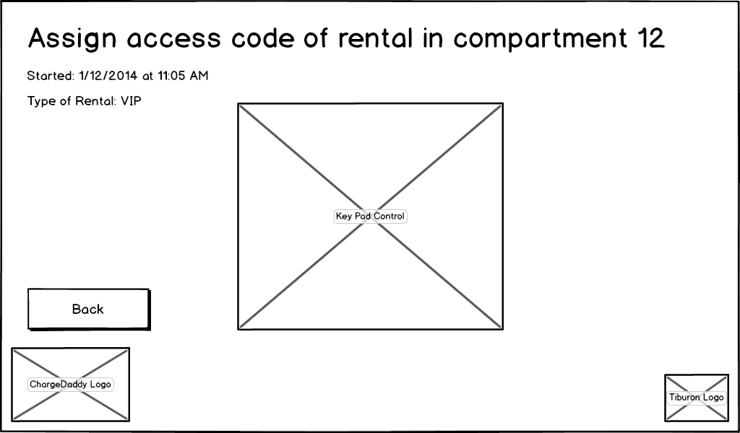
Figure 27: Assign New PIN page
Event: | Assign Access Code for a Rental
Description: | This page allows a Tiburon Admin or Venue Admin to change the access code / PIN for an active rental.
Pre-Conditions: | - The system is configured to allow PIN access to a locker / compartment.  - Tiburon Admin or Venue Admin has “clicked” the “Assign Pin” button on the Rental Details Page.
Success Path: |  | The page title reads “Assign access code of rental in locker [locker number]” for Electronic Lockers and “Assign access code of rental in [compartment number]” for ChargeDaddy.
The page instructions include
- “Started: [date] at [time]”
- Type of Rental: [type]”
 |  | The user enters a PIN code into the standard Access Code Keypad Control (refer to Administrative Login Page) and presses enter.
 |  | If passes validation, the user is prompted to re-enter their PIN.
 |  | The re-entered PIN is validated to ensure that it matches the previously entered PIN.
 |  | If does not pass validation, the user is informed and then prompted to start over with a new PIN.
 |  | If passes validation, the user is informed that a new PIN has been successfully assigned to locker / compartment [###].
 |  | The Rentals Page is displayed.
Alternate Path: |  | The user “clicks” the “Back” button and the Rental Details Page is displayed for the same locker / compartment number.

Select Cancel Rental Reason Page
This page is displayed to the user to request that they provide a reason for cancelling a rental through the Administrative page (instead of the customer retrieving their contents as usual).

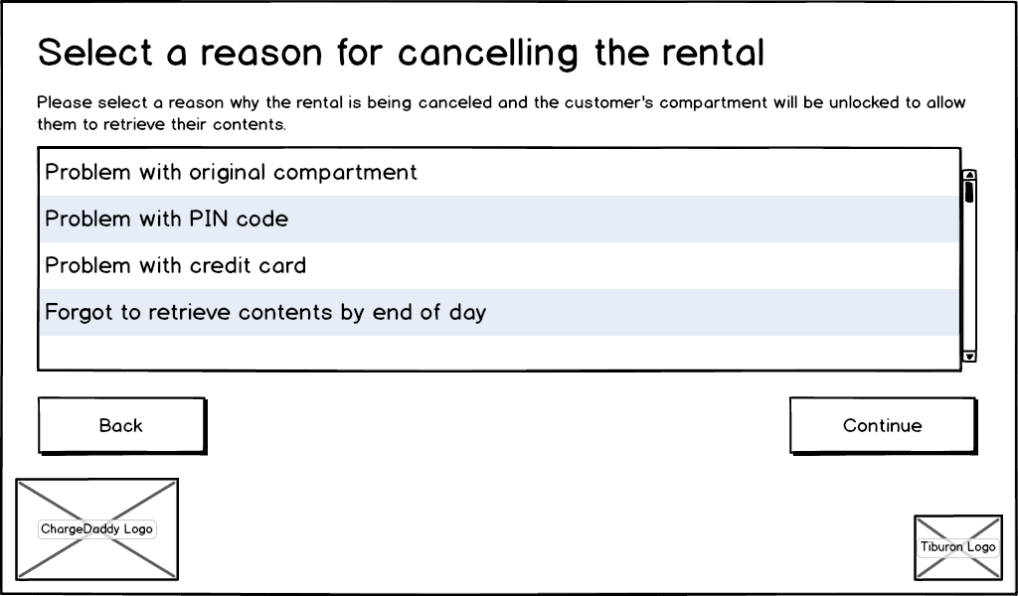
Figure 28: Select Cancel Rental Reason page

Event: | Select a Reason for an Administrative Cancel of Rental
Description: | This page allows a Tiburon Admin or Venue Admin to terminate a rental early so that a user may retrieve their device / items and not be charged. (this functionality is meant to be similar to Grant Free Rental Page except that it’s for an already rented compartment / locker – Per User Story 135)
Pre-Conditions: | - A Tiburon Admin or Venue Admin has selected “Cancel Rental” on the Rental Details Page.
Success Path: |  | The page text reads as indicated in Figure 28: Select Cancel Rental Reason page for ChargeDaddy. For Electronic Lockers, all instances of “compartment” should read “locker.”
 |  | The page instructions read as indicated in Figure 24: Grant Free Rental page for both ChargeDaddy and Electronic Lockers.
 |  | The following logos are displayed: ChargeDaddy (for ChargeDaddy) or Electronic Lockers (for Electronic Lockers), Tiburon Lockers.
 |  | The “Continue” button is disabled.
 |  | A list box for selecting a reason for cancelling the rental is displayed. Once a user selects a reason from this list, the “Continue” button is enabled. (Note: this is populated via a database lookup table which has been pre-populated from a list provided by Tiburon Lockers)
 |  | The user “clicks” the “Continue”
 |  | The Open Compartment Page is displayed.
Alternate Path: |  | The user “clicks” the “Back” button and the Rental Details Page is displayed.

Nightly Cleaning Page
This page is displayed to walk the administrator through the process of opening and closing each compartment to clean it.
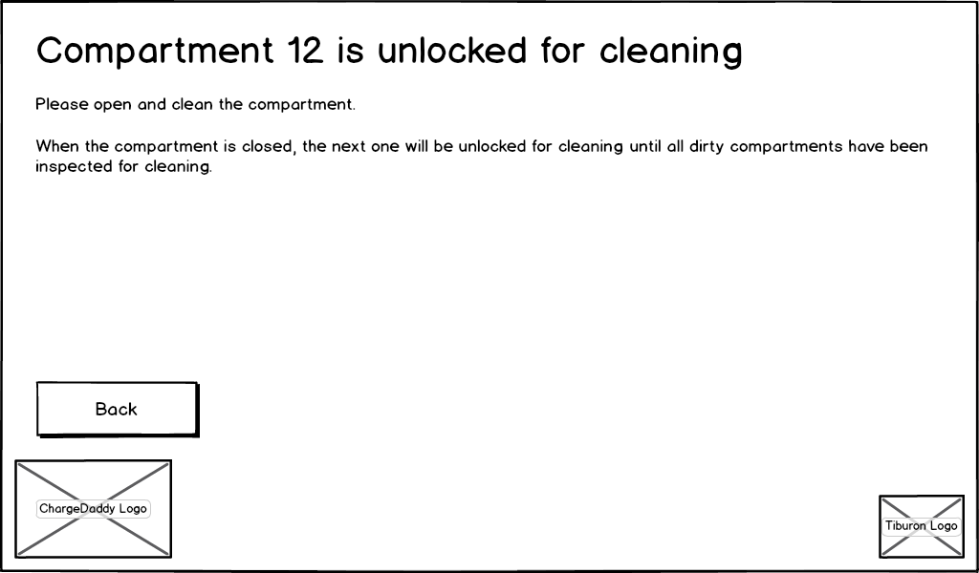
Figure 29: Nightly Cleaning page

Event: | Nightly Cleaning
Description: | This page allows a Tiburon Admin or Venue Admin to initiate a nightly cleaning process on all “dirty” lockers / compartments.
Pre-Conditions: | - Tiburon Admin or Venue Admin is logged into the kiosk application and “clicks” on the “Nightly Cleaning” button on the Administrative Home Page.
Success Path: |  | The page instructions read as indicated in Figure 28: Nightly Cleaning page for ChargeDaddy. For Electronic Lockers, all instances of “compartment” are replaced with “locker.”
 |  | The system determines which compartments / lockers are “Dirty”. If no lockers / compartments meet this criteria, refer to the first Alternate Path below. NOTE: refer to “Notes” section in this use case.
 |  | The page title reads “Compartment [compartment number] is unlocked for cleaning” for ChargeDaddy and “Locker [locker number] is unlocked for cleaning” for Electronic Lockers, where [compartment number / locker number] is the first number in the list returned.
 |  | The first compartment in the list returned is unlocked and its LED is flashed.
 |  | The user has a configurable timeout to open the compartment /locker before it is relocked and the Administrative Home Page is displayed.
 |  | If the timeout is not triggered, the user closes the compartment / locker.
 |  | The compartment / locker is locked and its LED set to the color appropriate for its status.
 |  | The system records that the compartment no longer requires cleaning.
 |  | The next compartment / locker in the list returned is passed and the process repeats until all lockers / compartments in the list returned have been opened and closed.
 |  | Once the cleaning process is complete, a message is displayed informing the user that the cleaning process is complete.
 |  | The user acknowledges the message and the Administrative Home Page is displayed.
Alternate Path: |  | If no compartments / lockers are found matching the criteria, the user is informed that no compartments / lockers require cleaning.
 |  | The user acknowledges the message and the Administrative Home Page is displayed.
Alternate Path: |  | The user “clicks” the “Back” button and the Administrative Home Page is displayed.
Assumptions: | - There will be no configurable time period in which the user must close the compartment – i.e. the locker can remain open indefinitely for a Nightly Cleaning function.
Notes: | The system determines which compartments / lockers, have been rented and their rentals have expired during the ending rental period, excluding rentals that are still active (i.e.. Multi-day rentals, if configured) and sets the locker / compartment “Is Dirty” flag. This logic is not handled on this screen

ChargeDaddy LED Color Definitions
Not Configured | -> | Available | -> | Unlocked | -> | Open | -> | Open > 15 Secs | -> | Charging | -> | Time > 1 Hour
Blinking Aqua |  | Blue |  | Blinking White |  | White |  | Blinking Red |  | Light Green |  | Green

Change Compartment Page
This page is displayed to prompt the user to select a reason why the compartment is being reassigned prior to it becoming unlocked.
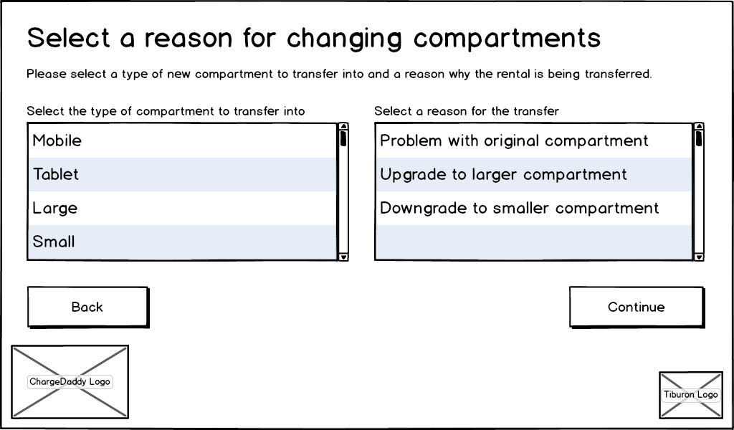
Event: | Reassign a Current Rental to Another Compartment / Locker
Description: | This page allows a Tiburon Admin or Venue Admin to reassign a current rental from one compartment / locker to another.
Pre-Conditions: | - Tiburon Admin or Venue Admin has “clicked” the “Change Compartment”(ChargeDaddy) / “Change Locker”(Electronic Lockers) button on the Rental Details Page.
Success Path: |  | The page title and instructions read as indicated for ChargeDaddy. For Electronic Lockers, all instances of “compartment” read “locker.
 |  | The “Continue” button is displayed in a disabled state.
 |  | The following logos are displayed: ChargeDaddy (for ChargeDaddy) or Electronic Lockers (for Electronic Lockers), Tiburon Lockers.
 |  | A scrollable list box is displayed with the title “Select a type of Compartment(ChargeDaddy) / Locker(Electronic Lockers) to transfer into.” This list box contains all compartment / locker types that the kiosk has as configured in the Add/Edit Compartment Page.
 |  | A scrollable list box is displayed with the title “Select a reason for the transfer.” This list box contains a list of all possible reasons for transferring from one compartment / locker to another (Note: this is populated via a database lookup table which has been pre-populated from a list provided by Tiburon Lockers).
 |  | The user selects a type of compartment / locker to transfer into.
 |  | The user selects a reason for the transfer.
 |  | The “Continue” button becomes enabled.
 |  | The user “clicks” the “Continue” button.
 |  | The system attempts to locate the “nearest” (in numerical terms of locker / compartment number, not lock number) available locker / compartment of type chosen. If the type of locker / compartment chosen is not available, a message will be displayed to the user, prompting them to try another type of locker / compartment or cancel the reassignment.
 |  | If the user cancels the reassignment, the Rental Details Page for the selected locker / compartment is displayed.
 |  | If the user elects to try another compartment type, start the process over.
 |  | The Move Contents page is displayed.
Alternate Path: |  | The user “clicks” the “Back” button and the Rental Details Page for the selected locker / compartment is displayed.
Assumptions: | Reassigning a rental from one kiosk to another will not be allowed in this functionality. For that functionality, refer to Floating a Rental.

Move Contents Page
This page is displayed to guide the user through moving their contents from one compartment to another.

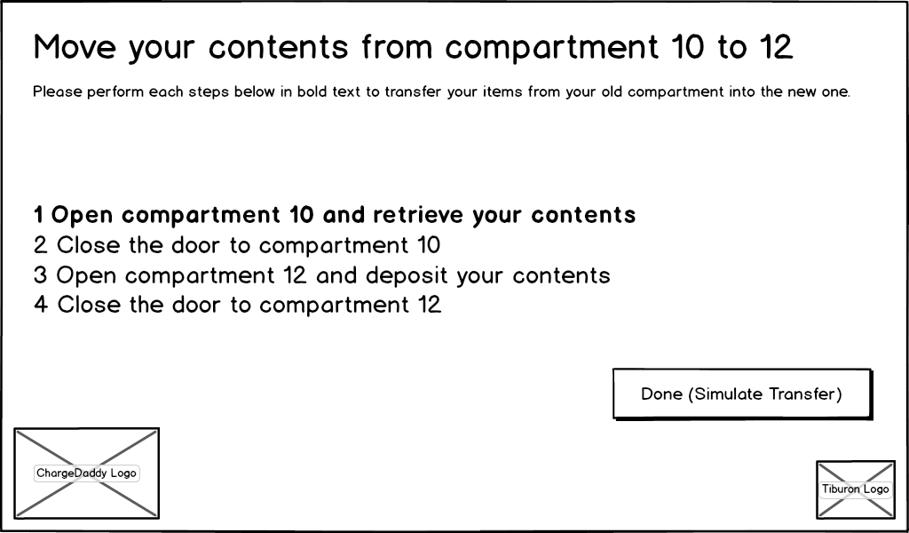
Figure 30: Move Contents page
Event: | Displaying the move contents page
Description: | Set the page in its initial state.
Success Path: |  | The page title and instructions read as indicated for ChargeDaddy. For Electronic Lockers, all instances of “compartment” read “locker”.
 |  | Labels that indicate the source and destination compartment reflect what was determined in the Change Compartment Page.
 |  | The following logos are displayed: ChargeDaddy (for ChargeDaddy) or Electronic Lockers (for Electronic Lockers), Tiburon Lockers.
 |  | The first numbered step in the list is set to bold font and the others are set back to normal font
 |  | The system unlocks the source compartment
 |  | The second numbered step in the list is set to bold font and the others are set back to normal font
 |  | The user closes the source compartment
 |  | The third numbered step in the list is set to bold font and the others are set back to normal font
 |  | The user opens the destination compartment
 |  | The fourth numbered step in the list is set to bold font and the others are set back to normal font
 |  | The system changes the compartment of the existing rental to the new compartment.
 |  | The user closes the destination compartment
 |  | The system displays the Rental Details Page.
Alternate Path: |  | The user never opens the source compartment
 |  | The Rental Details Page is displayed
Alternate Path: |  | The user never opens the destination compartment
 |  | The system records that the previous rental ended and calculates any pricing if it was an hourly or multi-day rental.
 |  | The Rental Details Page is displayed
Assumptions: | Reassigning a rental from one kiosk to another will not be allowed in this functionality. For that functionality, refer to Floating a Rental.

Hardware Settings Page
This page is displayed to allow the user to select from hardware settings to view and test using the kiosk administrative interface.
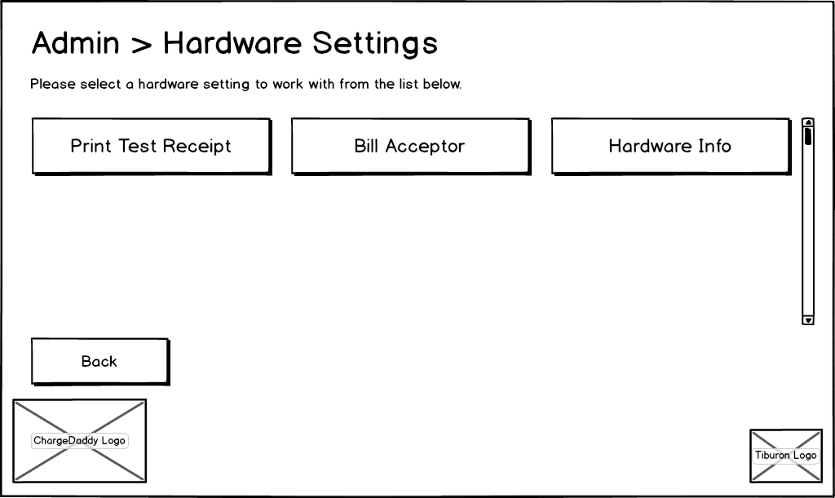
Figure 31: Hardware Settings page

Event: | Display Admin > Hardware Settings Page
Description: | This displays a page in which a Tiburon Admin or Venue Admin can navigate to various hardware function pages.
Pre-Conditions: | Tiburon Admin or Venue Admin is logged into the kiosk application and clicks the “Hardware Settings” button from the Administrative Home Page.
Success Path: |  | The page text reads as indicated in Figure 29: Hardware Settings page for both ChargeDaddy and Electronic Lockers.
 |  | If no receipt printer is configured for the kiosk, the “Print Test Receipt” button is not visible.
 |  | The following logos are displayed: ChargeDaddy (for ChargeDaddy) or Electronic Lockers (for Electronic Lockers), Tiburon Lockers.
 |  | The “Print Test Receipt” and “Bill Acceptor” buttons and functionality are not available / displayed for ChargeDaddy.
 |  | The user “clicks” the “Print Test Receipt” button.
 |  | A “faux receipt” is printed.
Alternate Path: |  | The user “clicks” the “Bill Acceptor” button.
 |  | The Bill Acceptor Page is displayed.
Alternate Path: |  | The user “clicks” the “Hardware Info” button.
 |  | The Hardware Info page is displayed.
Alternate Path: |  | The user “clicks” the “Back” button.
 |  | The Administrative Home Page is displayed.

Bill Acceptor Page
This page is displayed to allow the user to see how many bills of different denominations are in the bill acceptor and to request emptying it or testing it.

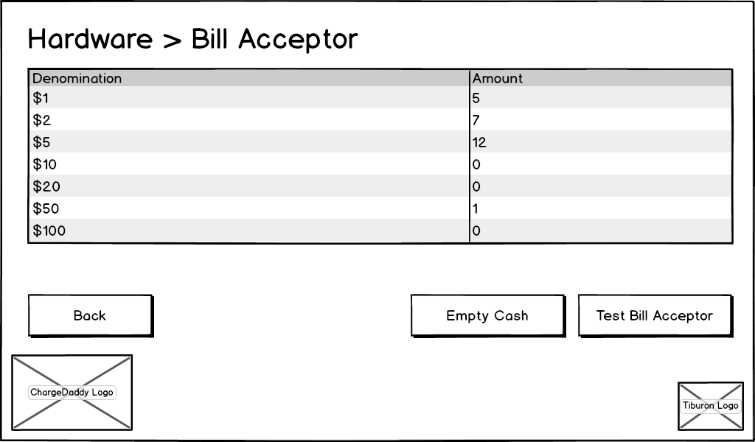
Figure 32: Bill Acceptor page

Event: | Display Hardware > Bill Acceptor Page (Electronic Lockers Only)
Description: | This page allows a Tiburon Admin or Venue Admin to view the count of various denomination bills currently in the bill acceptor as well as perform administrative functions.
Pre-Conditions: | Tiburon Admin or Venue Admin is logged into the kiosk application and clicks the “Bill Acceptor” button from the Hardware Settings Page.
Success Path: |  | The page text reads as indicated in Figure 31: Bill Acceptor page for Electronic Lockers.
 |  | A datagrid is displayed which gives a current count of each bill denomination as indicated in Figure 31: Bill Acceptor page.
 |  | The following logos are displayed: Electronic Lockers, Tiburon Lockers.
 |  | The user clicks the “Empty Cash” button.
 |  | The Bill Acceptor API is called to open it for emptying.
Alternate Path: |  | The user “clicks” the “Test Bill Acceptor” button.
 |  | The Test Bill Acceptor Page is displayed.
Alternate Path: |  | The user “clicks” the “Back” button.
 |  | The Hardware Settings Page is displayed.
Assumption: | We assume that by clicking Empty Cash, a call to the Bill Acceptor API will reset its counts of deposited bills.

Test Bill Acceptor Page
This page is displayed to prompt the user to put a bill into the bill acceptor and display the status of the test. It is also used to empty the cash and see the status of the bills in the acceptor.
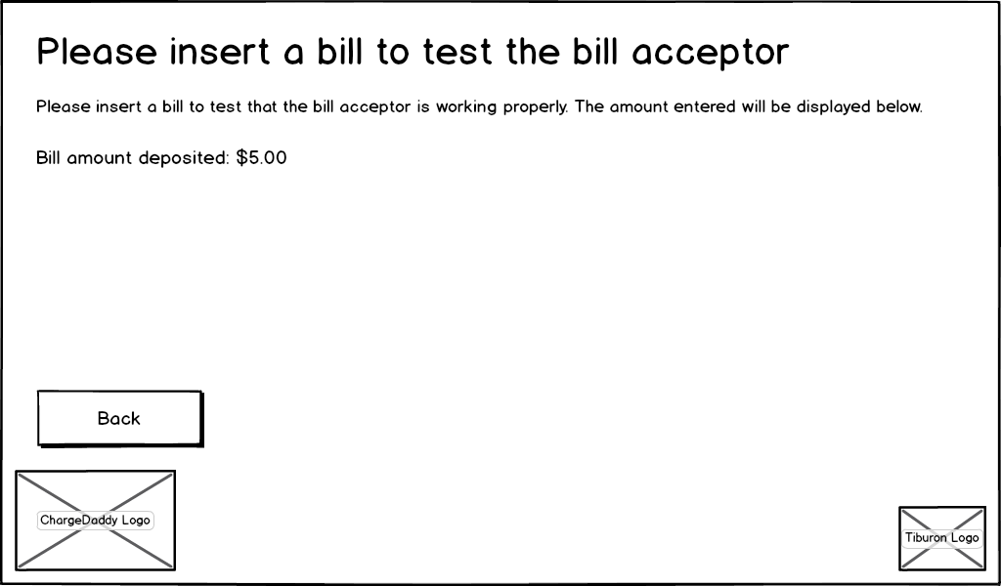
Figure 33: Test Bill Acceptor page

Event: | Test the Bill Acceptor (Electronic Lockers Only)
Description: | This page allows a Tiburon Admin or Venue Admin to test the bill acceptor on Electronic Lockers.
Pre-Conditions: | Tiburon Admin or Venue Admin is logged into the kiosk application and clicks the “Test Bill Acceptor” button from the Hardware Settings Page.
Success Path: |  | The page title and instructions read as indicated in Figure 30: Test Bill Acceptor page
 |  | The following logos are displayed: Electronic Lockers, Tiburon Lockers.
 |  | “Bill amount deposited: [amount]” is not displayed.
 |  | The bill acceptor is “turned on”.
 |  | The user feeds a bill into the bill acceptor.
 |  | “Bill amount deposited: [amount]” is displayed.
Alternate Path: |  | The user “clicks” the “Back” button.
 |  | The Bill Acceptor Page is displayed.

System Messages Page
This page is displayed to allow the administrator to configure system messages displayed to the user.

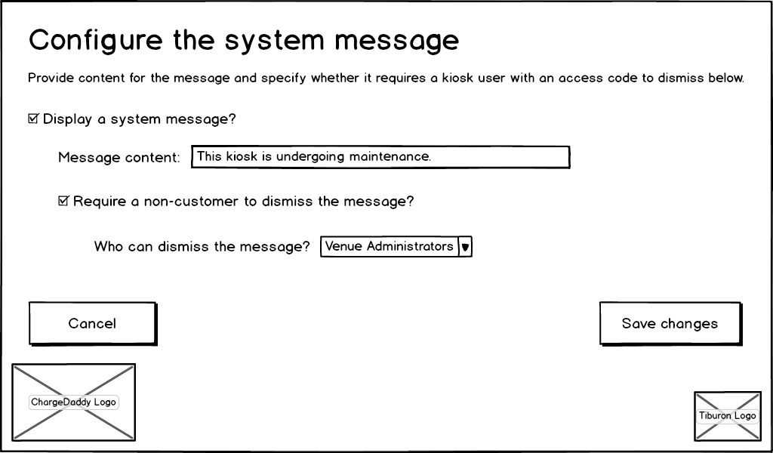
Figure 34: System Messages page

Event: | Configure the System Message.
Description: | This page allows a Tiburon Admin or Venue Admin to configure a system message to be displayed on the System Message Page.
Pre-Conditions: | Tiburon Admin or Venue Admin is logged into the kiosk application and clicks the “System Messages” button from the General Settings Page.
Success Path: |  | The “display a system message” checkbox indicates whether a message should be displayed on the System Message Page.
 |  | The “message content” textbox allows the user to type text which will be displayed if the “display a system message” checkbox is checked. If the “display a system message” checkbox is checked, this textbox is enabled and a required field, otherwise it is disabled and not required. This textbox will be blank if there is no saved system message and will be populated if there is a saved system message, regardless of whether the textbox is enabled or disabled.
 |  | The “require a non-customer to dismiss the message” checkbox indicates whether a user that is not logged in can dismiss a system message on the System Message Page.
 |  | The “who can dismiss the message” dropdown is enabled and required if the “require a non-customer to dismiss the message” is checked, otherwise it is disabled and not required. This dropdown is populated with the Venue Admin, Tiburon Admin, or Any Kiosk User.
 |  | The user “clicks” the “Save Changes” button.
 |  | The above logic is validated.
 |  | If all validation passes, the configuration on this screen will be saved to the database.
Alternate Path: |  | The user “clicks” the “Cancel” button.
 |  | The General Settings Page is displayed.
Assumptions: | When “require a non-customer to dismiss the message” is checked, the user must select a user role from the drop down menu. If Tiburon Admin is selected, only Tiburon Admin will be able to dismiss the message. If Venue Admin is selected, both Tiburon Admin and Venue Admin will be able to dismiss the message. If Any Kiosk User is selected, any user on the kiosk with a valid login PIN code can dismiss the message.
Notes: | If a system message should be shared by a group of kiosks, this will be handled automatically if those kiosks are enabled for floating as they can all share a single database to get system messages from.

Security Settings Page
This page is displayed to allow an administrator to select from other pages of the administration interface of the application to modify security settings.
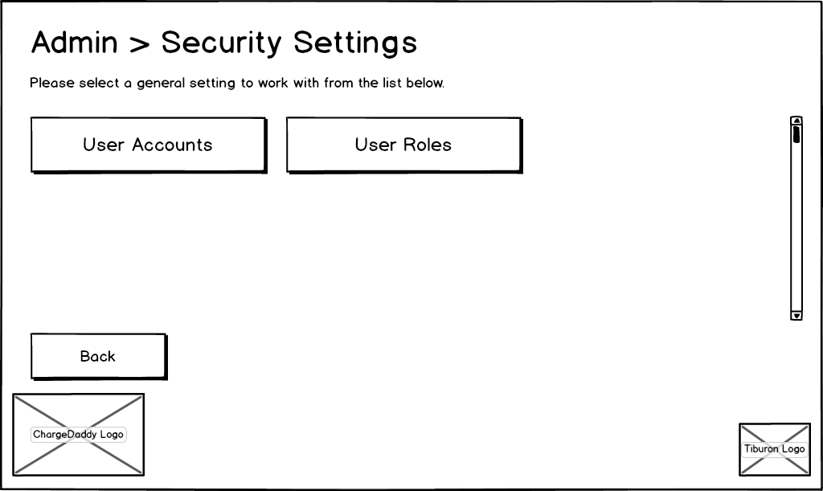
Figure 35: Security Settings page
Event: | Display Admin > Security Settings Page
Description: | This displays a page in which a Tiburon Admin or Venue Admin can navigate to various security / account function pages.
Pre-Conditions: | Tiburon Admin or Venue Admin is logged into the kiosk application and clicks the “Security Settings” button from the Administrative Home Page.
Success Path: |  | The page text reads as indicated in Figure 32: Security Settings page for both ChargeDaddy and Electronic Lockers.
 |  | If the user is not a Tiburon Admin, Venue Admin, or has not been granted the permission to “Manage Users” they will not see the “User Accounts” button.
 |  | If the user is not a Tiburon Admin, Venue Admin, or has not been granted the permission to “Manage Roles” they will not see the “User Roles” button.
 |  | The following logos are displayed: ChargeDaddy (for ChargeDaddy) or Electronic Lockers (for Electronic Lockers), Tiburon Lockers.
 |  | The user “clicks” the “User Accounts” button.
 |  | The List User Accounts Page is displayed.
Alternate Path: |  | The user “clicks” the “User Roles” button.
 |  | The List User Roles Page is displayed.
Alternate Path: |  | The user “clicks” the “Back” button.
 |  | The Administrative Home Page is displayed.

List User Accounts Page
This page is displayed to list the user accounts permitted to login to kiosk administration.

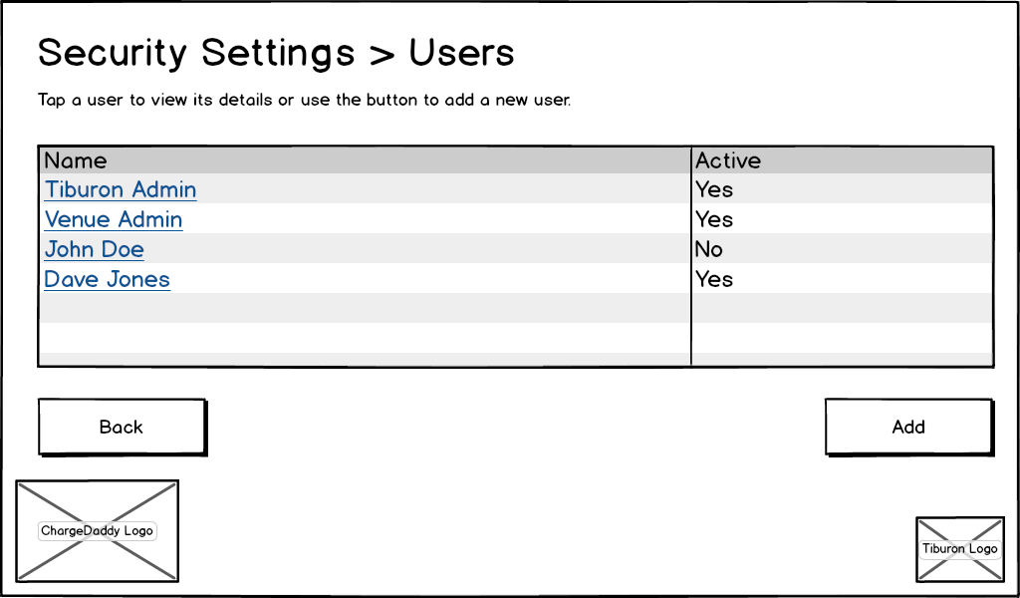
Figure 36: List User Accounts page

Event: | Display Security Settings > Users Page
Description: | This displays a page in which a Tiburon Admin or Venue Admin can view a list of user accounts on the kiosk and navigate to Add / Detail functions.
Pre-Conditions: | Tiburon Admin or Venue Admin is logged into the kiosk application and clicks the “User Accounts” button from the Security Settings Page.
Success Path: |  | The page text reads as indicated in Figure 33: List User Accounts page for both ChargeDaddy and Electronic Lockers.
 |  | The following logos are displayed: ChargeDaddy (for ChargeDaddy) or Electronic Lockers (for Electronic Lockers), Tiburon Lockers.
 |  | A scrollable datagrid is displayed which includes the user’s Name (first and Last) as well as whether the user is currently Active, indicated by Yes/No.
 |  | The user “double-clicks” on a row in the datagrid.
 |  | The Show User Account Page is displayed for the selected user.
Alternate Path: |  | The user “clicks” the “Add” button.
 |  | The Add/Edit User Account Page is displayed in “Add” mode.
Alternate Path: |  | The user “clicks” the “Back” button.
 |  | The Security Settings Page is displayed.

Add/Edit User Account Page
This page is displayed to create or edit a user account permitted to login to kiosk administration.
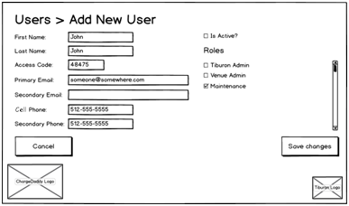
Figure 37: Add/Edit User Account page

Event: | Add New User
Description: | This function allows a new user account to be added to the local kiosk.
Pre-Conditions: | Tiburon Admin or Venue Admin is logged into the kiosk application and clicks the “Add” button from the List User Accounts Page.
Success Path: |  | The page text reads as indicated in Figure 34: Add/Edit User Account Page for both ChargeDaddy and Electronic Lockers.
 |  | The following logos are displayed: ChargeDaddy (for ChargeDaddy) or Electronic Lockers (for Electronic Lockers), Tiburon Lockers.
The following textboxes / labels are displayed:
- First Name (Required)
- Last Name (Required)
  - Note: First Name + Last Name must be unique per Kiosk, not venue, as accounts are stored locally on each kiosk)
- Access Code (Required – must be unique per User, venue wide – cannot exist for a different user anywhere at the venue, but can exist for the same user elsewhere at the venue)
- Primary Email (Required – must be unique per User, venue wide – cannot exist for a different user anywhere at the venue, but can exist for the same user elsewhere at the venue)
- Cell Phone (Required)
- Secondary Email (Not Required, does not have to be unique)
- Secondary Phone (Not Required)

An “Is Active?” checkbox is displayed (Unchecked by default).

A scrollable checkbox list containing all the Roles as configured for the kiosk on is displayed (Not Required).
 |  | The user fills out at least the required fields.
 |  | The user “clicks” the “Save Changes” button.
 |  | All of the entered data on the page is validated.
 |  | If any validation fails, the appropriate message is displayed to the user.
 |  | If passes all validation, the user is added to the kiosk database.
 |  | The List User Accounts Page is displayed.
Alternate Path: |  | The user “clicks” the “Cancel” button.
 |  | The List User Accounts Page is displayed.
Notes: | - One Tiburon Admin and one Venue Admin role is added by default to each new kiosk. At least one account with the Tiburon Admin role and at least one account with the Venue Admin role must always be active on the kiosk at all times.

Event: | Edit Existing User
Description: | This function allows an existing user account on the kiosk to be edited.
Pre-Conditions: | Tiburon Admin or Venue Admin is logged into the kiosk application and clicks the “Edit” button from the Show User Account Page.
Success Path: |  | The page title reads “Users > Edit “[FirstName] [LastName]”
 |  | The following logos are displayed: ChargeDaddy (for ChargeDaddy) or Electronic Lockers (for Electronic Lockers), Tiburon Lockers.
The following textboxes / labels are displayed and populated by the database entries for the selected user account:
- First Name (Required)
- Last Name (Required)
  - Note: First Name + Last Name must be unique per Kiosk, not venue, as accounts are stored locally on each kiosk)
- Access Code (Required – must be unique per User, venue wide – cannot exist for a different user anywhere at the venue, but can exist for the same user elsewhere at the venue)
- Primary Email (Required – must be unique per User, venue wide – cannot exist for a different user anywhere at the venue, but can exist for the same user elsewhere at the venue)
- Cell Phone (Required)
- Secondary Email (Not Required, does not have to be unique)
- Secondary Phone (Not Required)

An “Is Active?” checkbox is displayed.

A scrollable checkbox list containing all the Roles as configured for the kiosk.
 |  | The user makes any necessary edits the user account information.
 |  | The user “clicks” the “Save Changes” button.
 |  | All of the entered data on the page is validated.
 |  | If any validation fails, the appropriate message is displayed to the user.
 |  | If passes all validation, the user account information is updated in the database.
 |  | The List User Accounts Page is displayed.
Alternate Path: |  | The user “clicks” the “Cancel” button.
 |  | The List User Accounts Page is displayed.
Notes: | - One Tiburon Admin and one Venue Admin role is added by default to each new kiosk. At least one account with the Tiburon Admin role and at least one account with the Venue Admin role must always be active on the kiosk at all times.

Show User Account Page
This page is displayed to show the details of a user account permitted to login to kiosk administration.

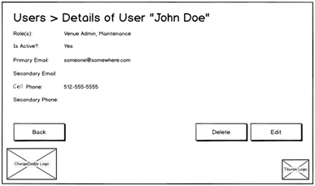
Figure 38: Show User Account page

Event: | View Details on an Existing User Account.
Description: | This function allows the details of an existing user account to be viewed, as well as performing a delete or navigating to a screen for editing the account information.
Pre-Conditions: | Tiburon Admin or Venue Admin is logged into the kiosk application and clicks the “Edit” button from the Show User Account Page.
Success Path: |  | The page title reads “Users > Details of User “[FirstName] [LastName]”
 |  | The following logos are displayed: ChargeDaddy (for ChargeDaddy) or Electronic Lockers (for Electronic Lockers), Tiburon Lockers.
The following labels are displayed and populated by the database entries for the selected user account:
- Roles (comma separated list for roles currently assigned to this account)
- Is Active?
- Primary Email
- Cell Phone
- Secondary Email
- Secondary Phone
 |  | The user “clicks” the “Delete” button
 |  | A message is displayed to the user prompting them if they are sure they wish to delete this account.
 |  | If the selected user account is the only user account on the kiosk with a role of Tiburon Admin or Venue Admin, it cannot be deleted, and a message indicating this is displayed to the user.
 |  | If the selected user account is NOT the only user account on the kiosk with a Venue Admin or Tiburon Admin role, the account is deleted.
 |  | The List User Accounts Page is displayed.
Alternate Path: |  | The user “clicks” the “Edit” button.
 |  | The Add/Edit User Account Page is displayed in “Edit” mode for the selected user account.
Alternate Path: |  | The user “clicks” the “Back” button.
 |  | The List User Accounts Page is displayed.
Notes: | One Tiburon Admin and one Venue Admin role is added by default to each new kiosk. At least one account with the Tiburon Admin role and at least one account with the Venue Admin role must always be active on the kiosk at all times.

List User Roles Page
This page is displayed to list the roles that can be assigned to user accounts permitted to login to the kiosk Administration pages.

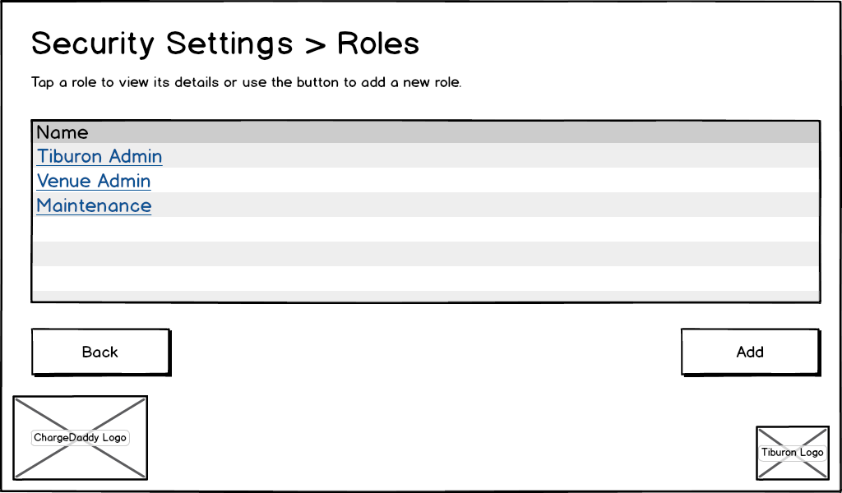
Figure 39: List User Roles page

Event: | Display Security Settings > Roles
Description: | This displays a page in which a Tiburon Admin or Venue Admin can view a list of user roles available on the kiosk and navigate to Add / Detail functions.
Pre-Conditions: | Tiburon Admin or Venue Admin is logged into the kiosk application and clicks the “User Roles” button from the Security Settings Page.
Success Path: |  | The page text reads as indicated in Figure 36: List User Roles page for both ChargeDaddy and Electronic Lockers.
 |  | The following logos are displayed: ChargeDaddy (for ChargeDaddy) or Electronic Lockers (for Electronic Lockers), Tiburon Lockers.
 |  | A scrollable datagrid is displayed which includes the Role name.
 |  | The user “double-clicks” on a row in the datagrid.
 |  | The Show User Role Page is displayed for the selected user.
Alternate Path: |  | The user “clicks” the “Add” button.
 |  | The Add/Edit User Role Page is displayed in “Add” mode.
Alternate Path: |  | The user “clicks” the “Back” button.
 |  | The Security Settings Page is displayed.

Add/Edit User Role Page
This page is displayed to create or edit a role that can be assigned to a user account permitted to login to the kiosk Administration pages.
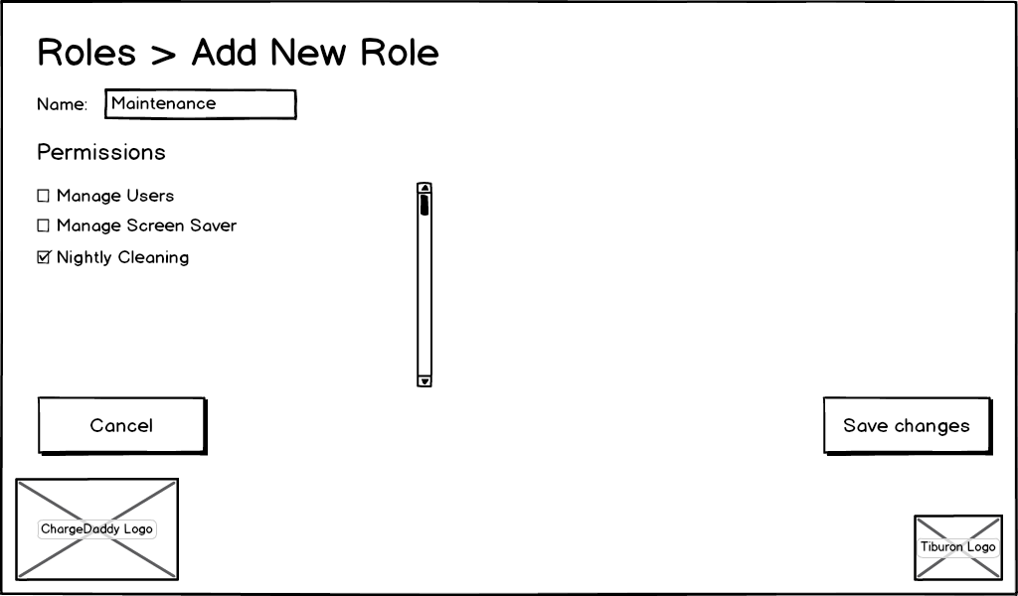
Figure 40: Add/Edit User Role page

Event: | Add New Role
Description: | This function allows a new role to be added to the local kiosk.
Pre-Conditions: | Tiburon Admin or Venue Admin is logged into the kiosk application and clicks the “Add” button from the List User Roles Page.
Success Path: |  | The page text reads as indicated in Figure 37: Add/Edit User Role page for both ChargeDaddy and Electronic Lockers.
 |  | The following logos are displayed: ChargeDaddy (for ChargeDaddy) or Electronic Lockers (for Electronic Lockers), Tiburon Lockers.
 |  | The “Name” textbox is displayed to capture the name for a new role. (Required – must be unique per kiosk, not venue, as accounts are stored locally on each kiosk)
A scrollable check list box containing all the permissions for the kiosk is displayed. (Note: this is populated via a database lookup table which has been pre-populated from a list provided by Tiburon Lockers)
- At least one Permission is required
- A Tiburon Admin can assign any permission to a role
- A Venue Admin can assign any permission to a role except for Tiburon Admin
 |  | The user “clicks” the “Save Changes” button.
 |  | All of the entered data on the page is validated.
 |  | If any validation fails, the appropriate message is displayed to the user.
 |  | If passes all validation, the role is added to the kiosk database.
 |  | The List User Roles Page is displayed.
Alternate Path: |  | The user “clicks” the “Cancel” button.
 |  | The List User Roles Page is displayed.
Notes: | One Tiburon Admin and one Venue Admin role is added by default to each new kiosk. At least one account with the Tiburon Admin role and at least one account with the Venue Admin role must always be active on the kiosk at all times.

Event: | Edit Existing Role
Description: | This function allows an existing role on the kiosk to be edited.
Pre-Conditions: | Tiburon Admin or Venue Admin is logged into the kiosk application and clicks the “Edit” button from the Show User Account Page.
Success Path: |  | The page title reads “Roles > Edit “[RoleName]”
 |  | The following logos are displayed: ChargeDaddy (for ChargeDaddy) or Electronic Lockers (for Electronic Lockers), Tiburon Lockers.
 |  | The “Name” textbox is displayed to allow editing for an existing role. (Required – must be unique per kiosk, not venue, as accounts are stored locally on each kiosk - populated by the database entry for the selected role)
A scrollable check list box containing all the permissions for the kiosk is displayed. (Note: this is populated via a database lookup table which has been pre-populated from a list provided by Tiburon Lockers, checked / unchecked as assigned in the database entries for the selected role)
- At least one Permission is required
- A Tiburon Admin can assign any permission to a role
- A Venue Admin can assign any permission to a role except for Tiburon Admin
- Permissions cannot be edited for a Tiburon Admin role or a Venue Admin role
 |  | The user “clicks” the “Save Changes” button.
 |  | All of the entered data on the page is validated.
 |  | If any validation fails, the appropriate message is displayed to the user.
 |  | If passes all validation, the role is updated in the kiosk database.
 |  | The List User Roles Page is displayed.
Alternate Path: |  | The user “clicks” the “Cancel” button.
 |  | The List User Roles Page is displayed.
Assumptions: | - Roles can be unique per kiosk and venue.  - Permissions are defined at an overall “Corporate” level.
Notes: | - One Tiburon Admin and one Venue Admin role is added by default to each new kiosk. At least one account with the Tiburon Admin role and at least one account with the Venue Admin role must always be active on the kiosk at all times.  - Permissions cannot be edited for a Tiburon Admin role or a Venue Admin role.

Show User Role Page
This page is displayed to show the details of a role that can be assigned to a user account permitted to login to the kiosk Administration pages.
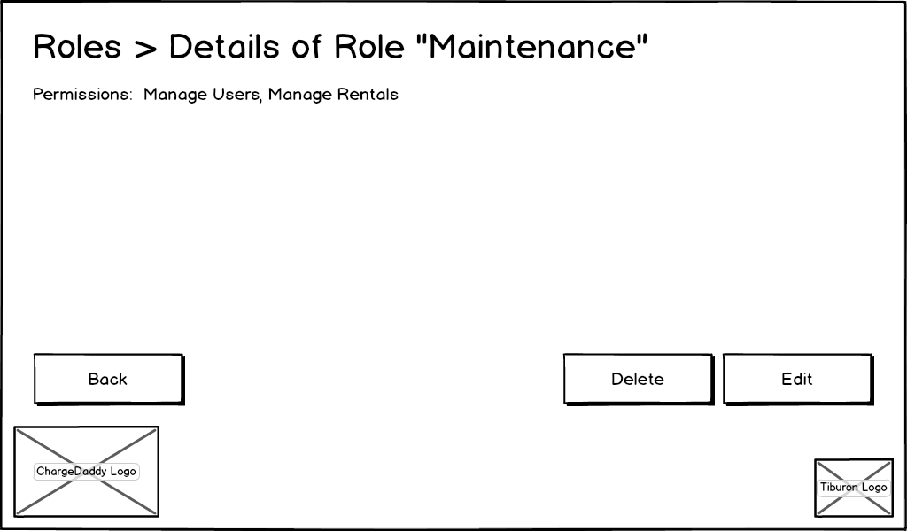
Figure 41: Show User Role page
Event: | View Details on an Existing Role
Description: | This function allows the details of an existing role to be viewed, as well as performing a delete or navigating to a screen for editing the role information.
Pre-Conditions: | Tiburon Admin or Venue Admin is logged into the kiosk application and clicks the “Edit” button from the Show User Role Page.
Success Path: |  | The page title reads “Roles > Details of User “[RoleName]”
 |  | The following logos are displayed: ChargeDaddy (for ChargeDaddy) or Electronic Lockers (for Electronic Lockers), Tiburon Lockers.
 |  | The “Permissions” label is displayed and populated as a comma separated list by the database entries for the selected role.
 |  | If the selected role is Tiburon Admin or Venue Admin, the “Delete” button is disabled.
 |  | The user “clicks” the “Delete” button
 |  | A message is displayed to the user prompting them if they are sure they wish to delete this role.
 |  | The List User Roles Page is displayed.
Alternate Path: |  | The user “clicks” the “Edit” button.
 |  | The Add/Edit User Role Page is displayed in “Edit” mode for the selected role.
Alternate Path: |  | The user “clicks” the “Back” button.
 |  | The List User Roles Page is displayed.
Assumptions: | - Roles can be unique per kiosk and venue.  - Permissions are defined at an overall “Corporate” level.
Notes: | - One Tiburon Admin and one Venue Admin role is added by default to each new kiosk. At least one account with the Tiburon Admin role and at least one account with the Venue Admin role must always be active on the kiosk at all times.  - Permissions cannot be edited for a Tiburon Admin role or a Venue Admin role.  - The Tiburon Admin and Venue Admin roles cannot be deleted.

Configure Advertising Page
This page is displayed to allow the administrator to configure the screen saver that displays advertisements when the kiosk is idle as well as a secondary monitor to display advertisements at all times.
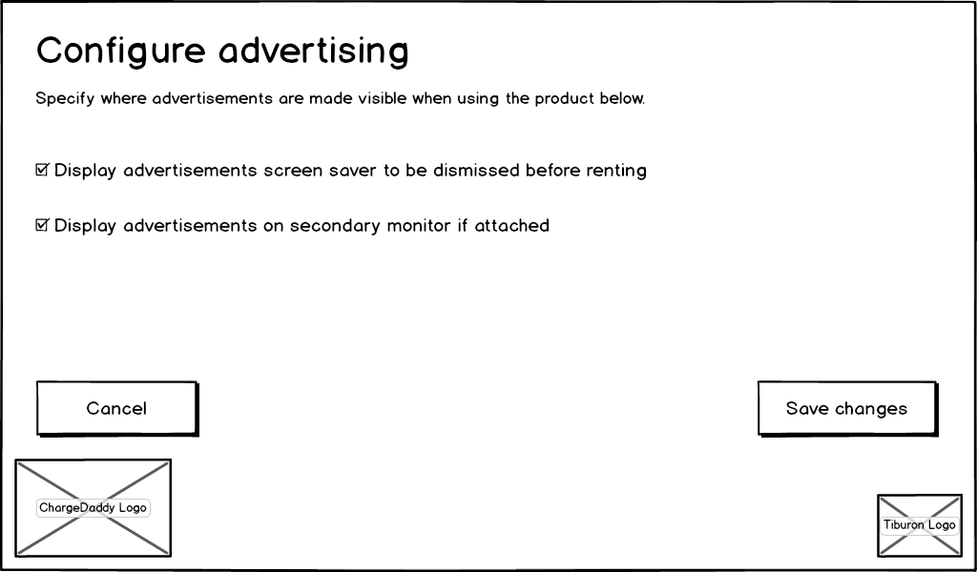
Figure 42: Configure Advertising page
Event: | Configure Advertising
Description: | This page allows a Tiburon Admin or Venue Admin to enable / disable advertising on both the primary kiosk and a secondary monitor.
Pre-Conditions: | Tiburon Admin or Venue Admin is logged into the kiosk application and clicks the “Advertising” button from the General Settings Page.
Success Path: |  | The page text reads as indicated in Figure 39: Configure Advertising page for both Electronic Lockers and ChargeDaddy.
 |  | The following logos are displayed: ChargeDaddy (for ChargeDaddy) or Electronic Lockers (for Electronic Lockers), Tiburon Lockers.
 |  | If the user “checks” the “Display advertisements screen saver to be dismissed before renting,” advertising images will be displayed on the Screen Saver Page.
 |  | If the user “checks” the “Display advertisements on a secondary monitor if attached” box, advertising images will be displayed on a secondary monitor if the supporting hardware is present (VGA, DVI, HDMI, etc).
 |  | The user “clicks” the “Save Changes” button and the settings are persisted to the database.
 |  | The General Settings Page is displayed.
Alternate Path: |  | The user “clicks” the “Cancel” button.
 |  | The General Settings Page is displayed.
Assumptions: | - Tiburon Admin has placed advertisement images in a directory  - Images will simply be rotated through – there will be no picking of order, randomizing, etc.

Configure Credit Processing Settings Page
This page is displayed to allow the administrator to configure settings about the payment processor that will be used to process credit cards when transactions are submitted for rentals.
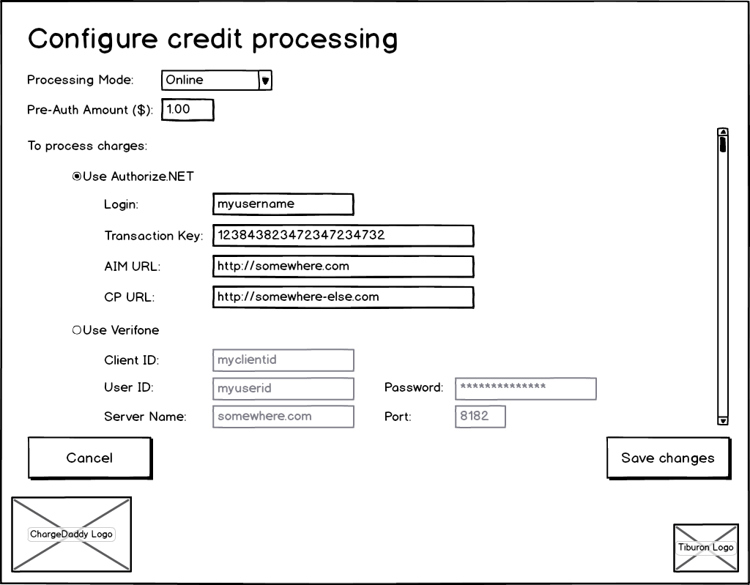
Figure 43: Configure Credit Processing Settings page

Event: | Configure Credit Card Processing
Description: | This page allows a Tiburon Admin or Venue Admin to configure credit card processing information.
Pre-Conditions: | Tiburon Admin or Venue Admin is logged into the kiosk application and clicks the “Credit Processing” button from the General Settings Page.
Success Path: |  | The page text reads as indicated in Figure 40: Configure Credit Processing Settings page for both Electronic Lockers and ChargeDaddy.
 |  | The following logos are displayed: ChargeDaddy (for ChargeDaddy) or Electronic Lockers (for Electronic Lockers), Tiburon Lockers.
 |  | The user enters a “pre-authorization” amount (in whatever currency the kiosk is configured to accept).
 |  | The user selects EITHER “Use Authorize.Net” radio button OR “Use Verifone” radio button.
 |  | The user enters the required information for each provider.
 |  | The user “clicks” the “Save Changes” button.
 |  | All of the settings on the page are persisted to the local kiosk database.
 |  | The user “clicks” the “Save Changes” button and the settings are persisted to the database.
 |  | The General Settings Page is displayed.
Alternate Path: |  | The user “clicks” the “Cancel” button.
 |  | The General Settings Page is displayed.
Assumptions: | - We will rely on the credit card processor blacklist and not maintain our own.  - If a connection is not available, then the transaction is recorded as normal but the request times out. When a connection is restored, the kiosk will attempt to reconcile the transaction.  - The credit card processor handles different currency types / exchange rates on its own, outside of our system.  - All fields on the page are assumed to be required and fully inclusive of what Verifone and Authorize.Net need to function. These were taken from the existing Tiburon applications.  - All fields required for the credit card processor configuration are interpreted as strings and no validation is done to ensure they are a “valid port” or “valid URL” etc.
Notes: | The page will not allow the user to save it if a payment provider (Authorize.NET / Verifone) is selected but any of the fields for that provider are empty.

Configure Express Station
This page is displayed to allow the administrator to configure a kiosk as an express station that can be used only for retrieving of contents of a locker or compartment that was previously rented.
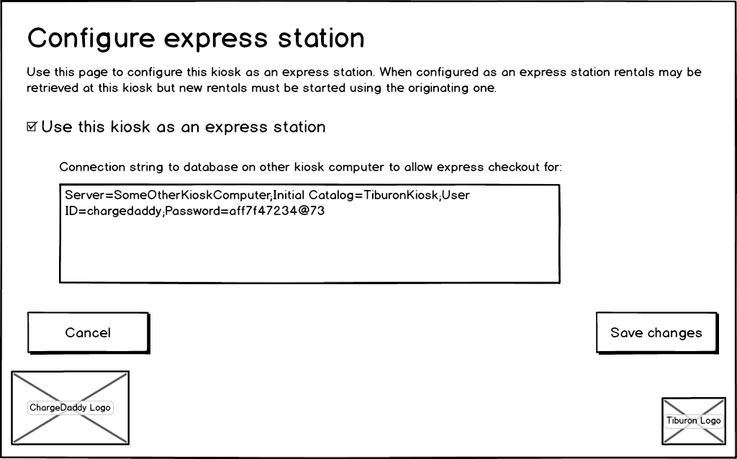
Figure 44: Configure Express Station page

Event: | Configure Express Station
Description: | This page allows a Tiburon Admin or Venue Admin to configure a second kiosk or remote terminal (tablet) to function as an “Express Station,” (a kiosk which will allow checkout of a rental and limited admin functionality only).
Pre-Conditions: | Tiburon Admin or Venue Admin is logged into the kiosk application and clicks the “Express Station” button from the General Settings Page.
Success Path: |  | The page text reads as indicated in Figure for both Electronic Lockers and ChargeDaddy.
 |  | The following logos are displayed: ChargeDaddy (for ChargeDaddy) or Electronic Lockers (for Electronic Lockers), Tiburon Lockers.
 |  | If the user “checks” the “Use this kiosk as an express station,” the connection string text box becomes enabled and required.
 |  | The user enters the connection string to point to the local kiosk database for the kiosk that this kiosk will act as an express station for.
 |  | The user “clicks” the “Save Changes” button.
 |  | The kiosk attempts to make a connection to the database using the specified connection string.
 |  | If the connection cannot be made, the settings are not saved, the user is notified that the database could not be reached, and they are left on the same screen.
 |  | If the connection can be made, the settings are saved, the user is notified that the settings were saved successfully, the General Settings Page is displayed.
Alternate Path: |  | The user “clicks” the “Cancel” button.
 |  | The General Settings Page is displayed.
Assumptions: | - A second kiosk or remote terminal (tablet) is available  - The user will be able to access the Admin screen and login using their access code PIN, however the only options available to them when the kiosk is configured in Express mode will be the Express mode settings and exiting the application.  - The user will only be able to end a rental where they can use an access code PIN. If the method for ending a rental is with a credit card, they will need to do this at the original kiosk.
Notes: | The “Express Station” may be a full installation of a kiosk or a remote terminal (tablet) with limited functionality, we need to ensure that this limited functionality is called out on the screens where it is applicable.  - When the Home Page is displayed on the express station, the rent option will not be available.  - When the customer retrieves the locker or compartment's contents at the express station, a row is inserted into a table on the kiosk that is connected to the hardware to request opening of the locker or compartment.  - The Open Compartment Page is displayed asking the customer to open the locker or compartment and retrieve the contents.  - If the compartment is never opened and times out, the row in the database on the kiosk connected to the hardware has a status column updated to signify that.  - If the compartment is opened and then closed, the row in the database on the kiosk connected to the hardware has a status column updated to signify that.  - The express station polls the database to check the status of the row related to the operation it requested until it is updated to signify that the compartment was closed or timed out.  - The rental process continues as described in the user story "Renting a single compartment" based on the status of the previous two steps.

Hardware Info Page
This page is displayed to the user to allow them to see which hardware devices are enabled and if they are, which COM port they are configured to communicate with.

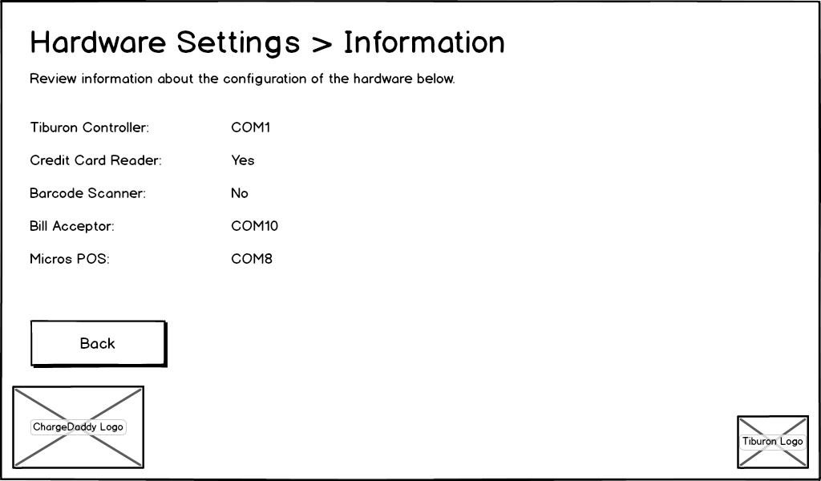
Figure 45: Hardware Info page

Event: | Display Hardware Settings > Information Page
Description: | This page allows a Tiburon Admin or Venue Admin to view read-only hardware setting information for the kiosk.
Pre-Conditions: | Tiburon Admin or Venue Admin is logged into the kiosk application and clicks the “Hardware Settings” button from the Administrative Home Page.
Success Path: |  | The page title and instructions read as indicated in Figure 44: Hardware Info page for both Electronic Lockers and ChargeDaddy.
 |  | The following logos are displayed: ChargeDaddy (for ChargeDaddy) or Electronic Lockers (for Electronic Lockers), Tiburon Lockers.
 |  | A label for each hardware device for the kiosk is displayed.
 |  | If a hardware device is not COM port dependent (i.e. uses USB HID driver), it is listed as either “Yes” for available or “No” for not available.
 |  | If a hardware is configured on a specific COM port, that port is listed.
 |  | The user “clicks” the “Back” button and the Administrative Home Page is displayed.

Version Info Page
This page is displayed to the user to allow them to see what version and environment the kiosk application is running under.

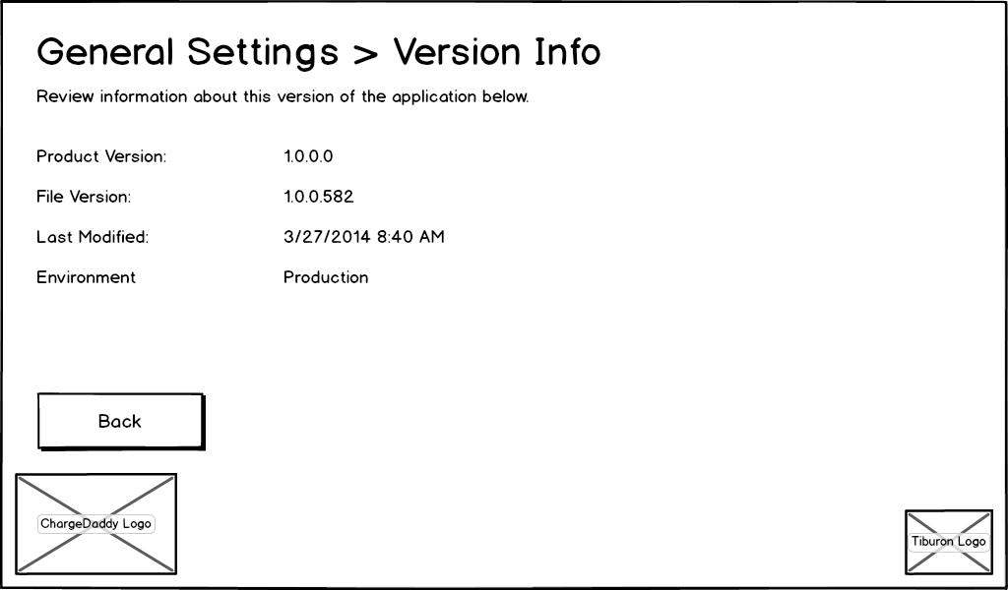
Figure 46: Version Info page

Select Venue Page
This page is displayed to allow the Tiburon Administrator to select the venue where the kiosk will be installed during initial setup to test it prior to sending to a customer.
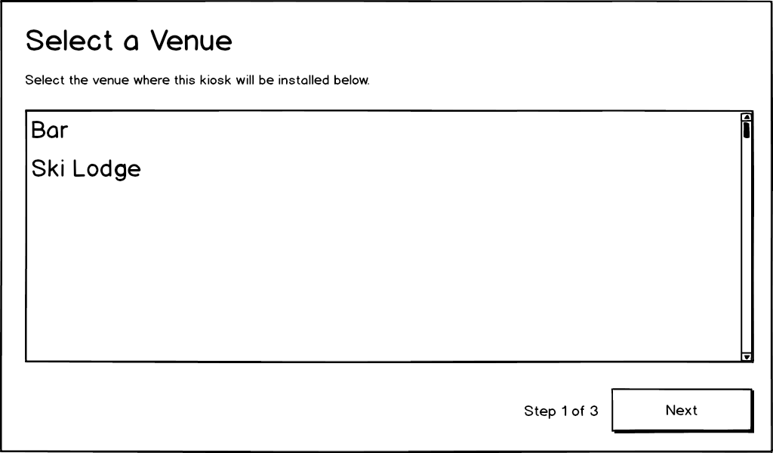
Figure 47: Select Venue page

Event: | Select A Venue
Description: | The user selects the venue from the list of all venues
Pre-Conditions: | This page is displayed when running the application for the first time on a kiosk, or when a user selects to Change Kiosk from the General Settings Page
Success Path: |  | The user selects a venue from the list of all venues
 |  | The next button becomes enabled when a venue is selected.
 |  | The user hits Next and is taken to the Select Product Page.

Select Product Page
This page is displayed to allow the Tiburon Administrator to select the product that will be installed during initial setup to test it prior to sending to a customer.
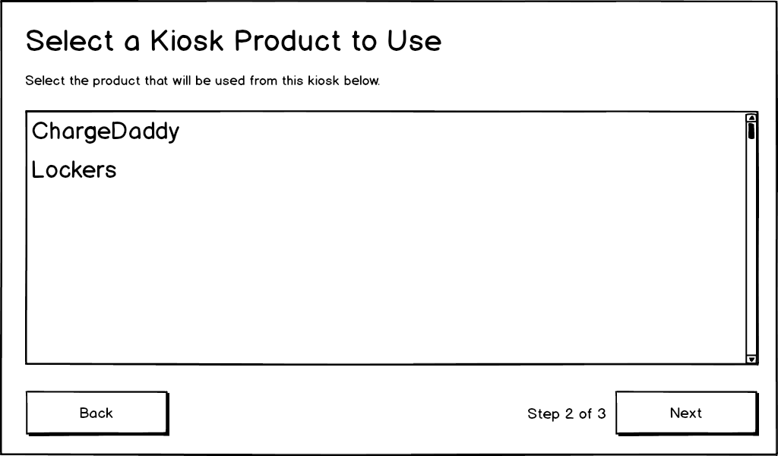
Figure 48: Select Product page

Event: | Select A Product
Description: | The user selects the Product from the list of all products
Pre-Conditions: | This page is displayed when running the application for the first time on a kiosk after selecting the venue, or when a user selects to Change Kiosk from the General Settings Page and selects the venue
Success Path: |  | The user selects a product from the list of all products
 |  | The next button becomes enabled when a product is selected.
 |  | The user hits Next and is taken to the Select Kiosk Page.

Event: | Back
Description: | The user hits the back button to return to the select venue page
Pre-Conditions: | This page is displayed when running the application for the first time on a kiosk after selecting the venue, or when a user selects to Change Kiosk from the General Settings Page and selects the venue
Success Path: |  | The user hits Back button
 |  | The user is taken to the Select Venue Page.

Select Kiosk Page
This page is displayed to allow the Tiburon Administrator to select the kiosk during initial setup to test it prior to sending to a customer.

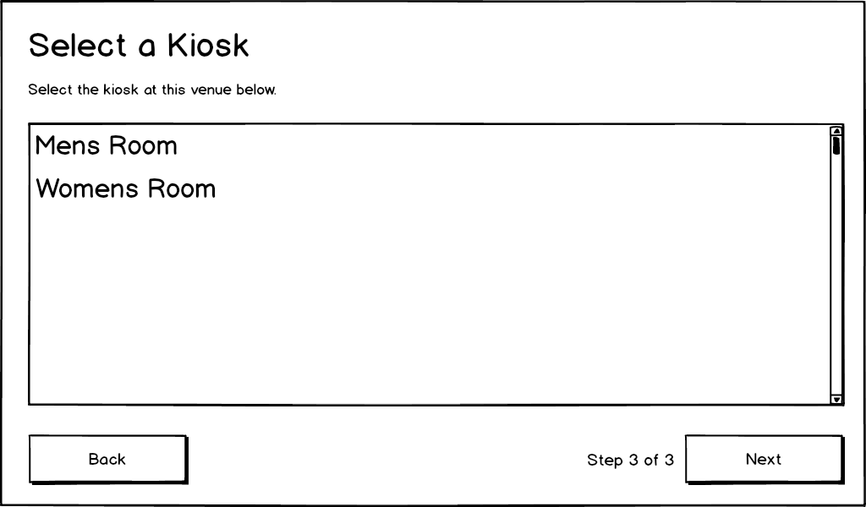
Figure 49: Select Kiosk page

Event: | Select A Kiosk
Description: | The user selects the Kiosk from the list of all kiosks of the chosen product type at the selected venue
Pre-Conditions: | This page is displayed when running the application for the first time on a kiosk after selecting the venue and product, or when a user selects to Change Kiosk from the General Settings Page and selects the venue and product
Success Path: |  | The user selects a kiosk from the list of all kiosks
 |  | The next button becomes enabled when a kiosk is selected.
 |  | The user hits Next and is taken to the Home Page.
Alternate Path: |  | The user selects a kiosk from the list of all kiosks of the chosen product type at the selected venue
 |  | The next button becomes enabled when a kiosk is selected.
 |  | The user hits Next and is taken to the System Message Page if a message already exists for this kiosk and is configured to display

Event: | Back
Description: | The user hits the back button from select kiosk page to return to the select product page
Pre-Conditions: | This page is displayed when running the application for the first time on a kiosk after selecting the venue and product, or when a user selects to Change Kiosk from the General Settings Page and selects the venue and product
Success Path: |  | The user hits Back button
 |  | The user is taken to the Select Product Page.

